

Asp.Net Submission

Government Polytechnic, Gandhinagar



Jagani Ishan Jigneshkumar

196230316042

GOVERNMENT POLYTECHNIC, GANDHINAGAR



***CERTIFICATE***

*This is to certify that Mr. / Ms.* ***Jagani Ishan Jigneshkumar*** *having*

*Enrollment No* ***: 196230316042*** *has completed his/her practical work for subject* ***“Web Programming Using ASP.Net”,*** *subject code* ***“3351603”*** *during his/her 5th Semester satisfactorily in*

*his/her term ending at Date 30/09/2021 for the year 2021.*

***__ / __ / ____*** *Darshak B. Mehta*

***DATE OF SUBMISSION****:* ***SIGNATURE OF FACULTY***

|  |  |  |  |  |
| --- | --- | --- | --- | --- |
| Table of Contents | | | | |
| Sr.no | Practical: Aim | Page Number | Date | Signature |
| 1 | Getting acquainted with Visual Studio environment. (create new web project, open existing web project, building website, and study of toolbars, menu etc.) | 5-21 |  |  |
| 2 | Develop simple application using .net facility | 22-24 |  |  |
| 3 | Develop simple web page using built in Objects | 25-26 |  |  |
| 4 | Design a web form to allow user to enter following details in his Resume using Web Server Controls. Set validations using properties. When data is submitted it must be viewed in the panel below the form. Fields of Resume are FirstName, Surname, Gender, Address, City, Pincode, Phone, Qualification (Diploma, Bachelor, Master), Specialization subject, Percentage. | 27-30 |  |  |
| 5 | Create a web form where user enters following marks. ASP.NET, JAVA, ISS, Project (All out of 100). When user submits the marks, numeric value validation must be done. On entering marks, the grade should be displayed in message box . % > 90 and <<=100  AA > 80 and <<=90  AB > 70 and <<=80  BB > 60 and <<=67  BC >50 and <<=60  CC >40 and <= 50 DD  Else Fail | 31-33 |  |  |
| 6 | Create a Simple calculator with validations and details | 34-36 |  |  |
| 7 | Create a web page using the concept of cascading style sheets in ASP.NET | 37-38 |  |  |
| 8 | Create a web page using the concept of Theme & Skin in ASP.NET | 39-40 |  |  |
| 9 | Create Home page of your website using master page concept | 41-43 |  |  |
| 10 | Create a simple web application to illustrate the concept of nesting master page in ASP.NET | 44-45 |  |  |
| 11 | Develop a web page to implement the concept of state management using Cookies | 46-47 |  |  |
| 12 | Develop a web page to implement the concept of state management using Session and Application | 48-49 |  |  |
| 13 | Develop a web page to implement the concept of state management using ViewState and QueryString | 50-52 |  |  |
| 14 | Create a web application using Global.asax file which will count the number of visitors on web page. | 53-54 |  |  |
| 15 | Use various tags in Web.config file for ASP.NET configuration. | 55-56 |  |  |
| 16 | Write sample application to connect to database (connection object), Fetching and inserting data from database (command object) and using Data Reader | 57-60 |  |  |
| 17 | Create a Web page and test the connectivity of your database with biodata form in exercise 1. If connected, display the message that connection with database is successful, and redirect the user to his homepage | 61-63 |  |  |
| 18 | Create a login page in your web application. Login page must have user name and password fields. If user enters correct ID, Password, he must be redirected to the homepage of your website. | 64-66 |  |  |
| 19 | Create a web page to insert user biodata information with all validations in to the database | 67-70 |  |  |
| 20 | Create a webpage, that allows user to add a new username if user doesn’t exist in the database. Also create a forgot password link, to redirect user to set up his new password on authentication | 71-77 |  |  |
| 21 | Create a webpage to display the information about user on his homepage once he has logged in through the login form | 78-80 |  |  |
| 22 | Write an exercise, to allow the user to ADD, UPDATE, MODIFY his profile once he has logged into the website using Bound and Unbound Controls | 81-87 |  |  |
| 23 | Create a webpage to bind the user data from database into a gridview dynamically. | 88-89 |  |  |

Practical : 1

**AIM: Getting acquainted with Visual Studio environment. (Create new web project, open existing web project, building website, and study of toolbars, menu etc.)**

This walkthrough provides you with an introduction to Microsoft Visual Web Developer. It guides you through creating a simple page by using Visual Web Developer, illustrating the basic techniques of creating a new page, adding controls, and writing code.

Tasks illustrated in this walkthrough include:

* Creating a file system Web site.
* Familiarizing yourself with Visual Web Developer.
* Creating a single-file ASP.NET page in Visual Web Developer.
* Adding controls.
* Adding event handlers.
* Running pages with the Web Servers in Visual Web Developer.
* The .NET Framework

## Creating a Web Site and Page

In this part of the walkthrough, you will create a Web site and add a new page to it. You will also add HTML text and run the page in your Web browser.

For this walkthrough, you will create a file system Web site that does not require that you work with Microsoft Internet Information Services (IIS). Instead, you will create and run your page in the local file system.

A file system Web site is one that stores pages and other files in a folder that you choose somewhere on your local computer. Other Web site options include a local IIS Web site, which stores your files in a subfolder of the local IIS root (typically, \Inetpub\Wwwroot\). An FTP site stores files on a remote server that you gain access to across the Internet by using File Transfer Protocol (FTP). A remote site stores files on a remote server that you can access across a local network. For more information, see Walkthrough: Editing Web Sites with FTP in Visual Web Developer. Also, Web site files can be stored in a source control system such as Visual SourceSafe. For more information, see Introducing Source Control.

**To create a file system Web site**

1. Open Visual Web Developer.
2. On the File menu, click New Web Site.

The New Web Site dialog box appears, as shown in the following screen shot.

### New Web Site dialog box

The programming language you choose will be the default for your Web site. However, you can use multiple languages in the same Web application by creating pages and components in different programming languages.

3.

Under Visual Studio installed templates, click ASP.NET Web Site.

When you create a Web site, you specify a template. Each template creates a Web

application that contains different files and folders. In this walkthrough, you are creating

a Web site based on the ASP.NET Web Site template, which creates some folders and a

few default files.

4.

In the Location box, select the File System box, and then enter the name of the folder

where you want to keep the pages of your Web site.

For example, type the folder name C:\BasicWebSite.

5.

In the Language list, select Visual Basic or Visual C#.

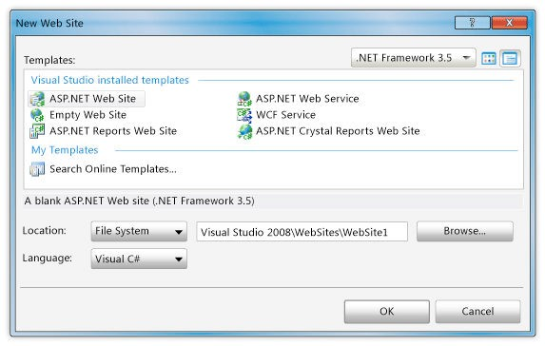

6. Click OK.

Visual Web Developer creates the folder and a new page named Default.aspx. When a new page is created, by default Visual Web Developer displays the page in Source view, where you can see the page's HTML elements. The following screen shot shows the Source view of a default Web page.

### Source view of default page

**A Tour of Visual Web Developer**

Before you proceed with working on the page, it is useful to familiarize yourself with the Visual

Web Developer development environment. The following illustration shows you the windows

and tools that are available in Visual Web Developer.

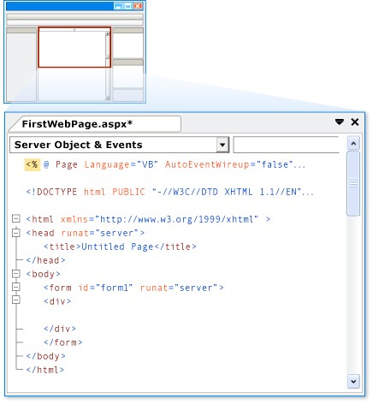

This diagram shows default windows and window locations. The View menu allows you to display additional windows, and to rearrange and resize windows to suit your preferences. If changes have already been made to the window arrangement, what you see will not match the diagram.

### Diagram of Visual Web Developer environment

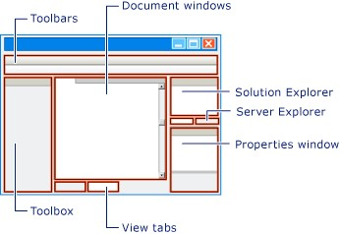

**To familiarize yourself with the Web designer in Visual Web Developer**

• Examine the preceding illustration and match the text to the following list, which describes the most commonly used windows and tools. (Not all windows and tools that you see are listed here, only those marked in the preceding illustration.) o Toolbars. Provide commands for formatting text, finding text, and so on. Some toolbars are available only when you are working in Design view.

* Solution Explorer. Displays the files and folders in your Web site.
* Document window. Displays the documents you are working on in tabbed windows. You can switch between documents by clicking tabs. o Properties window. Allows you to change settings for the page, HTML elements, controls, and other objects. o View tabs. Present you with different views of the same document. Design view is a near-WYSIWYG editing surface. Source view is the HTML editor for the page. Split view displays both the Design view and the Source view for the document. You will work with the Design and Source views later in this walkthrough. If you prefer to open Web pages in Design view, on the Tools menu, click Options, select the HTML Designer node, and change the Start Pages In option. o Toolbox. Provides controls and HTML elements that you can drag onto your page. Toolbox elements are grouped by common function. o Server Explorer/Database Explorer. Displays database connections. If Server Explorer is not visible in Visual Web Developer, on the View menu, click Server Explorer or Database Explorer.

**Creating a New Web Forms Page**

When you create a new Web site, Visual Web Developer adds an ASP.NET page (Web Forms page) named Default.aspx. You can use the Default.aspx page as the home page for your Web site. However, for this walkthrough, you will create and work with a new page.

**To add a page to the Web site**

1. Close the Default.aspx page. To do this, right-click the tab containing the file name and select Close.
2. In Solution Explorer, right-click the Web site (for example, C:\BasicWebSite), and then click Add New Item.
3. Under Visual Studio installed templates, click Web Form. The following screen shot

shows the Add New Item dialog box.

Add New Item dialog box

4.

In the Name box, type FirstWebPage.

5.

In the Language list, choose the programming language you prefer to use (Visual Basic,

C#, or J#). When you created the Web site, you specified a default language. However,

each time you create a new page or component for your Web site, you can change the

language from the default. You can use different programming languages in the same

Web site.

6.

Clear the Place code in separate file check box.

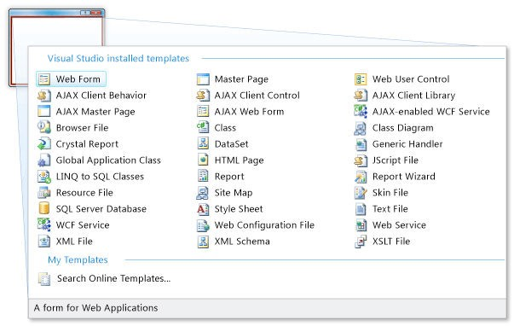

In this walkthrough, you are creating a single-file page with the code and HTML in the same page. The code for ASP.NET pages can be located either in the page or in a separate class file. To learn more about keeping the code in a separate file, see Walkthrough: Creating a Basic Web Page with Code Separation in Visual Web Developer. 7. Click Add.

Visual Web Developer creates the new page and opens it.

**Adding HTML to the Page**

In this part of the walkthrough, you will add some static text to the page.

**To add text to the page**

1.

At the bottom of the document window, click the Design tab to switch to Design view.

Design view displays the page that you are working on in a WYSIWYG-like way. At this

point, you do not have any text or controls on the page, so the page is blank except for a

dashed line that outlines a rectangle. This rectangle represents a div element on the page.

2.

Click inside the rectangle that is outlined by a dashed line.

3.

Type Welcome to Visual Web Developer and press Enter twice.

The following screen shot shows the text you typed in Design view.

Welcome text as seen in Design view

4.

Switch to Source view.

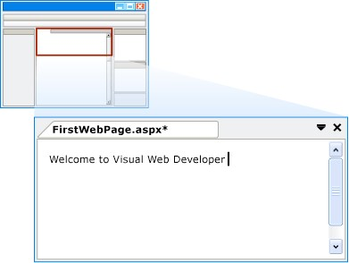

You can see the HTML that you created by typing in Design view, as shown in the following screen shot.

### Welcome text as seen in Source view

**Running the Page**

Before you proceed with adding controls to the page, you can try running it. To run a page, you

need a Web server. In a production Web site, you use IIS as your Web server. However, to test a

page, you can use the ASP.NET Development Server, which runs locally and does not require

IIS. For file system Web sites, the default Web server in Visual Web Developer is the ASP.NET

Development Server.

**To run the page**

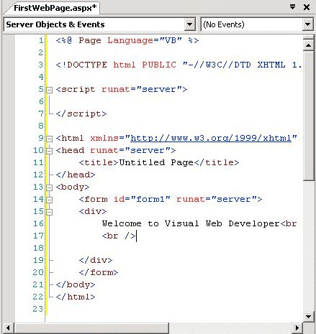

1. In Solution Explorer, right-click FirstPage.aspx and select Set as Start Page.
2. Press CTRL+F5 to run the page.

Visual Web Developer starts the ASP.NET Development Server. An icon appears on the toolbar to indicate that the Visual Web Developer Web server is running, as shown in the following screen shot.

### Visual Web Developer Web server icon

The page is displayed in the browser. Although the page you created has an extension of .aspx, it currently runs like any HTML page.

To display a page in the browser you can also right-click the page in Solution Explorer and select View in Browser.

If the browser displays a 502 error or an error indicating that the page cannot be displayed, you might need to configure your browser to bypass proxy servers for local requests. For details, see How to: Bypass a Proxy Server for Local Web Requests.

3. Close the browser.

## Adding and Programming Controls

In this part of the walkthrough, you will add a Button, a TextBox, and a Label control to the page and write code to handle the Click event for the Button control.

You will now add server controls to the page. Server controls, which include buttons, labels, text boxes, and other familiar controls, provide typical form-processing capabilities for your ASP.NET Web pages. However, you can program the controls with code that runs on the server, not the client.

**To add controls to the page**

1. Click the Design tab to switch to Design view.
2. Put the insertion point at the end of the Welcome to Visual Web Developer text and press ENTER five or more times to make some room in the div element box.
3. In the Toolbox, expand the Standard group.
4. Drag a TextBox control onto the page and position it in the middle of the div element box that has Welcome to Visual Web Developer in the first line.
5. Drag a Button control onto the page and position it to the right of the TextBox control.
6. Drag a Label control onto the page and position it on a separate line below the Button control.
7. Put the insertion point above the TextBox control, and then type Enter your name:.

This static HTML text is the caption for the TextBox control. You can mix static HTML and server controls on the same page. The following screen shot shows how the three controls appear in Design view.

### Controls in Design View

**Setting Control Properties**

Visual Web Developer offers you various ways to set the properties of controls on the page. In

this part of the walkthrough, you will set properties in both Design view and Source view.

**To set control properties**

1.

Select the Button control, and then in the Properties window, set Text to Display Name,

as shown in the following screen shot.

Changed Button control text

2.

Switch to Source view.

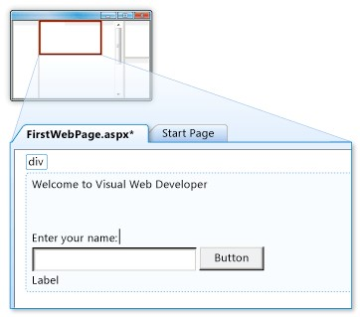

Source view displays the HTML for the page, including the elements that Visual Web Developer has created for the server controls. Controls are declared using HTML-like syntax, except that the tags use the prefix asp: and include the attribute runat="server".

Control properties are declared as attributes. For example, when you set the Text property for the Button control, in step 1, you were actually setting the Text attribute in the control's markup.

Note that all the controls are inside a <form> element, which also has the attribute runat="server". The runat="server" attribute and the asp: prefix for control tags mark the controls so that they are processed by ASP.NET on the server when the page runs. Code outside of <form runat="server"> and <script runat="server"> elements is sent whose opening tag contains the runat="server" attribute.

unchanged to the browser, which is why the ASP.NET code must be inside an element

3.

Put the insertion point after asp:Label in the <asp:Label> tag, and then press

SPACEBAR.

A drop-down list appears that displays the list of properties you can set for a Label

control. This feature, referred to as IntelliSense, helps you in Source view with the syntax

of server controls, HTML elements, and other items on the page. The following screen

shot shows the IntelliSense drop-down list for the Label control.

IntelliSense for Label control

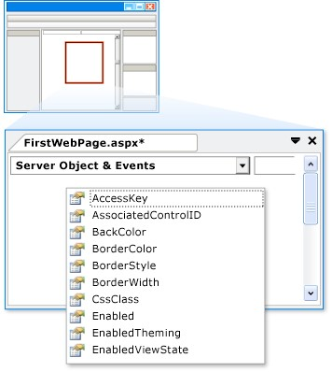

1. Select ForeColor and then type an equal sign and a quotation mark (="). IntelliSense displays a list of colors.

**Note:**

You can display an IntelliSense drop-down list at any time by pressing CTRL+J.

1. Select a color for the Label control's text. Make sure you select a color that is dark enough to read against a white background.

The ForeColor attribute is completed with the color that you have selected, including the closing quotation mark.

**Programming the Button Control**

For this walkthrough, you will write code that reads the name that the user enters into the text box and then displays the name in the Label control.

**To add a default button event handler**

1. Switch to Design view.
2. Double-click the Button control.

Visual Web Developer switches to Source view and creates a skeleton event handler for the Button control's default event, the Click event.

**Note:**

Double-clicking a control in Design view is just one of several ways you can create event handlers.

1. Inside the handler, type the following:

Label1.

When you type the period after Label, Visual Web Developer displays a list of available members for the Label control, as shown in the following screen shot.

### Available Label control members

4.

Finish the Click event handler for the button so that it reads as shown in the following

code example.

VB

Protected

Sub

Button1_Click(

ByVal

sender

As

Object

,

ByVal

e

As

System.EventArgs)

Label1.Text = Textbox1.Text &

", welcome to Visual Web Developer!"

End

Sub

C#

protected

void

Button1_Click(

object

sender, System.EventArgs e)

{

Label1.Text = TextBox1.Text +

", welcome to Visual Web Developer!"

;

}

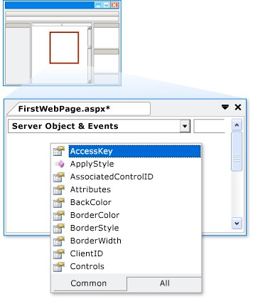

5. Scroll down to the <asp:Button> element. Note that the <asp:Button> element now has the attribute OnClick="Button1_Click". This attribute binds the button's Click event to the handler method you coded in step 4.

Event handler methods can have any name; the name you see is the default name created by Visual Web Developer. The important point is that the name used for the OnClick attribute must match the name of a method in the page.

If you are using Visual Basic with code separation, Visual Web Developer does not add an explicit OnClick attribute. Instead, the event is bound to the handler method using a Handles keyword on the handler declaration itself.

**Running the Page**

You can now test the server controls on the page.

**To run the page**

1. Press CTRL+F5 to run the page in the browser.

The page again runs using the ASP.NET Development Server.

1. Enter a name into the text box and click the button.

The name you entered is displayed in the Label control. Note that when you click the button, the page is posted to the Web server. ASP.NET then recreates the page, runs your code (in this case, the Button control's Click event handler runs), and then sends the new page to the browser. If you watch the status bar in the browser, you can see that the page is making a round trip to the Web server each time you click the button.

1. In the browser, view the source of the page you are running.

In the page source code, you see only ordinary HTML; you do not see the <asp:> elements that you were working with in Source view. When the page runs, ASP.NET processes the server controls and renders HTML elements to the page that perform the functions that represent the control. For example, the <asp:Button> control is rendered as the HTML element <input type="submit">.

1. Close the browser.

## Working with Additional Controls

In this part of the walkthrough, you will work with the Calendar control, which displays dates a month at a time. The Calendar control is a more complex control than the button, text box, and label you have been working with and illustrates some further capabilities of server controls.

In this section, you will add a Calendar control to the page and format it.

**To add a Calendar control**

1. In Visual Web Developer, switch to Design view.
2. From the Standard section of the Toolbox, drag a Calendar control onto the page and position it below the div element that contains the other controls:

The calendar's smart tag panel is displayed. The panel displays commands that make it

easy for you to perform the most common tasks for the selected control. The following

screen shot shows the Calendar control as rendered in Design view.

Calendar control in Design view

3.

In the smart tag panel, choose Auto Format.

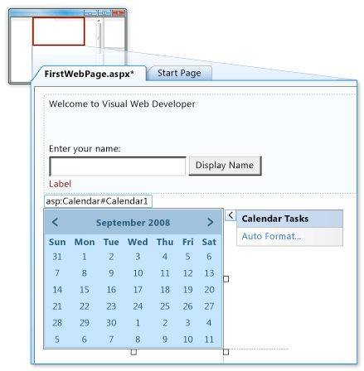

The Auto Format dialog box is displayed, which allows you to select a formatting scheme for the calendar. The following screen shot shows the Auto Format dialog box for the Calendar control.

### Auto Format dialog box for the Calendar control

4.

From the Select a scheme list, select Simple and then click OK.

5.

Switch to Source view.

You can see the <asp:Calendar> element. This element is much longer than the elements

for the simple controls you created earlier. It also includes subelements, such as

<

WeekEndDayStyle>, which represent various formatting settings. The following screen

shot shows the Calendar control in Source view.

Calendar control in Source view

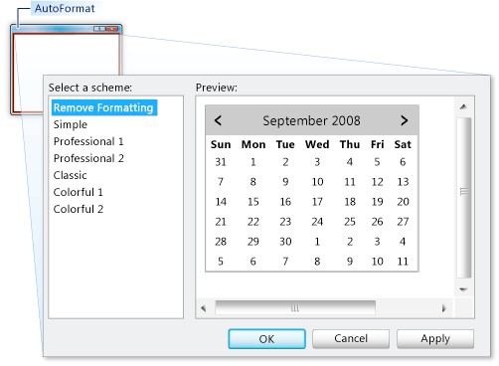

**Programming the Calendar Control**

In this section, you will program the Calendar control to display the currently selected date.

**To program the Calendar control**

1.

In Design view, double-click the Calendar control.

A new event handler is created in Source view.

2.

Finish the SelectionChanged event handler with the following highlighted code.

VB

Protected

Sub

Calendar1_SelectionChanged(

ByVal

sender

As

Object

,

ByVal

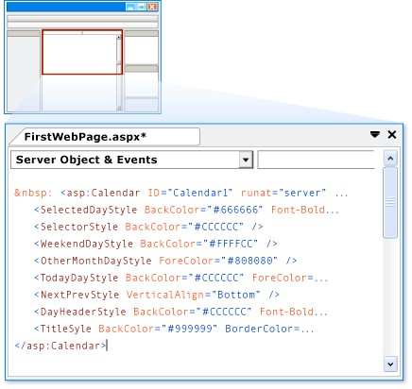

e As System.EventArgs)

Label1.Text = Calendar1.SelectedDate.ToLongDateString()

End Sub

### C#

protected void Calendar1_SelectionChanged(object sender,

System.EventArgs e)

{

Label1.Text = Calendar1.SelectedDate.ToLongDateString(); }

**Running the Page**

You can now test the calendar.

**To run the page**

1.

Press CTRL+F5 to run the page in the browser.

2.

Click a date in the calendar.

The date you clicked is displayed in the Label control.

3.

In the browser, view the source code for the page.

Note that the Calendar control has been rendered to the page as a table, with each day as

a <td> element containing an <a> element.

4.

Close the browser.

|  |  |  |  |
| --- | --- | --- | --- |
| Start Date | End/Sign Date | Faculty Sign | Remarks/Grade |
|  |  |  |  |

Practical : 2

##### **Aim: Develop Simple Application Using .net Facility.**

Login.aspx

<%@ Page Language="vb" AutoEventWireup="false" CodeBehind="Login.aspx.vb" Inherits="Practical_2.Login" %>

<!DOCTYPE html>

<html xmlns="http://www.w3.org/1999/xhtml">

<head runat="server">

<title></title>

</head>

<body>

<form id="form1" runat="server">

<div>

Username :

<asp:TextBox ID="TextBox1" runat="server"></asp:TextBox>

<br />

Password :

<asp:TextBox ID="TextBox2" runat="server" TextMode="Password"></asp:TextBox>

<br />

<br />

<asp:Button ID="Button1" runat="server" Text="Login" />

</div>

</form>

</body>

</html>

Login.aspx.vb

Public Class Login

Inherits System.Web.UI.Page

Protected Sub Page_Load(ByVal sender As Object, ByVal e As System.EventArgs) Handles Me.Load

End Sub

Protected Sub Button1_Click(sender As Object, e As EventArgs) Handles Button1.Click

Response.Redirect("Home.aspx")

End Sub

End Class

Home.aspx

<%@ Page Language="vb" AutoEventWireup="false" CodeBehind="Home.aspx.vb" Inherits="Practical_2.Home" %>

<!DOCTYPE html>

<html xmlns="http://www.w3.org/1999/xhtml">

<head runat="server">

<title></title>

</head>

<body>

<form id="form1" runat="server">

<div>

Welcome to Ishan's Website

<asp:Button ID="btnURL" runat="server" Text="Log Out" />

<br />

<br />

Enter Your Birth Year :

<asp:Button ID="calVisible" runat="server" Text="..." />

<asp:Calendar ID="cal" runat="server" visible="false" />

<br />

<asp:Button ID="btnSubmit" runat="server" Text="Submit" />

</div>

</form>

</body>

</html>

[Home.aspx.vb](http://Home.aspx.vb)

Public Class Home

Inherits System.Web.UI.Page

Protected Sub Page_Load(ByVal sender As Object, ByVal e As System.EventArgs) Handles Me.Load

End Sub

Protected Sub calVisible_Click(sender As Object, e As EventArgs) Handles calVisible.Click

cal.Visible = True

End Sub

Protected Sub btnURL_Click(sender As Object, e As EventArgs) Handles btnURL.Click

Response.Redirect("Login.aspx")

End Sub

End Class

Output :

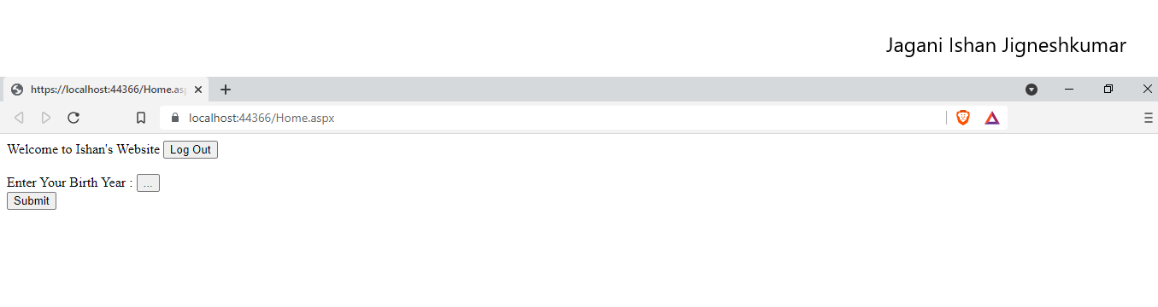

On Pressing Log Out Button :

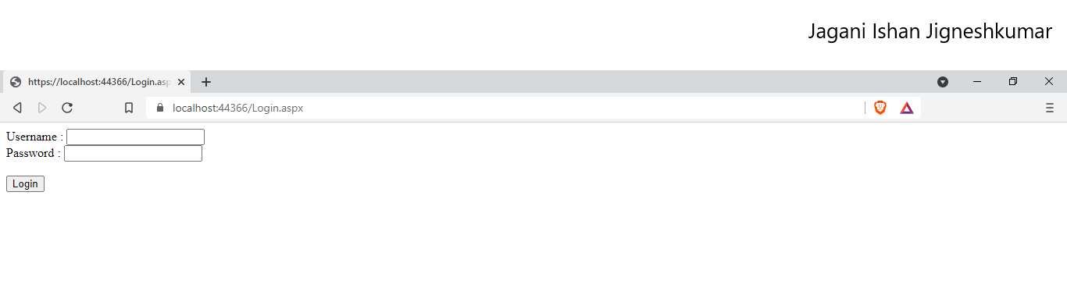

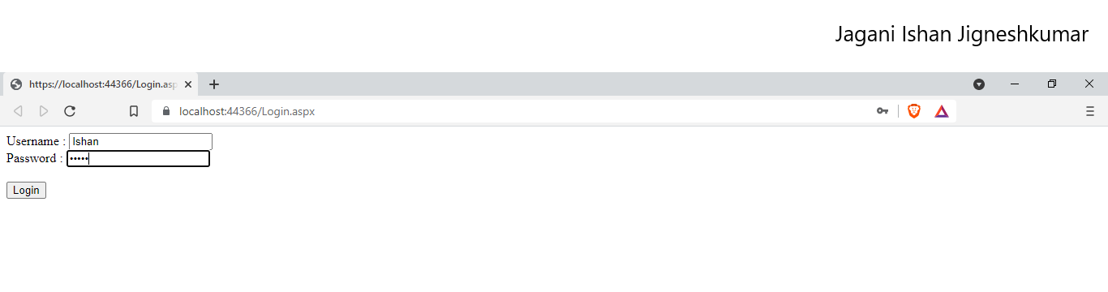

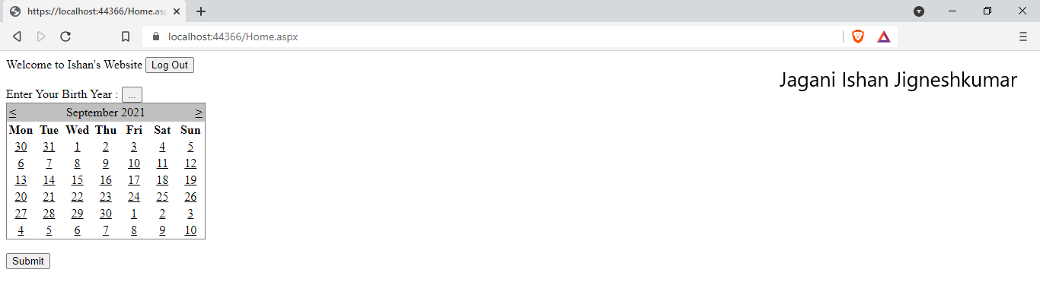

|  |  |  |  |
| --- | --- | --- | --- |
| Start Date | End/Sign Date | Faculty Sign | Remarks/Grade |
|  |  |  |  |

Practical : 3

#### **Aim: Develop simple web page using built in Objects.**

First.aspx

<%@ Page Language="vb" AutoEventWireup="false" CodeBehind="First.aspx.vb" Inherits="Practical_3.First" %>

<!DOCTYPE html>

<html xmlns="http://www.w3.org/1999/xhtml">

<head runat="server">

<title></title>

</head>

<body>

<form id="form1" runat="server">

<div>

</div>

</form>

</body>

</html>

First.aspx.vb

Public Class First

Inherits System.Web.UI.Page

Protected Sub Page_Load(ByVal sender As Object, ByVal e As System.EventArgs) Handles Me.Load

Response.Write("<br />Server Mappath : " & Server.MapPath("\"))

Response.Write("<br />Server Machine Name : " & Server.MachineName)

Response.Write("<br />Server Script Time Out : " & Server.ScriptTimeout)

Response.Write("<br />Trace Enabled? : " & Trace.IsEnabled)

Response.Write("<br />Trace Mode : " & Trace.TraceMode)

Response.Write("<br />Client Certificate : " & Request.ClientCertificate.ToString)

Response.Write("<br />Request HTTP Method : " & Request.HttpMethod)

End Sub

End Class

Output :

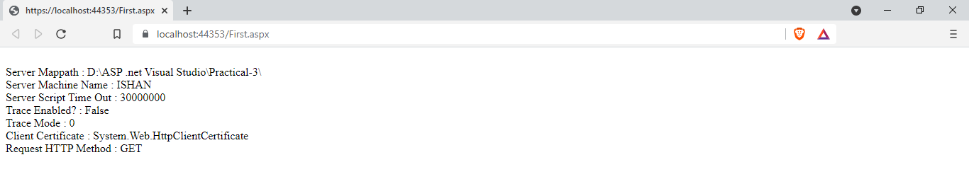

|  |  |  |  |
| --- | --- | --- | --- |
| Start Date | End/Sign Date | Faculty Sign | Remarks/Grade |
|  |  |  |  |

Practical : 4

#### **Aim : Design a web form to allow user to enter following details in his Resume using Web Server Controls. Set validations using properties. When data is submitted it must be viewed in the panel below the form. Fields of Resume are FirstName, Surname, Gender, Address, City, Pincode, Phone, Qualification (Diploma, Bachelor, Master), Specialization subject, Percentage.**

Resume.aspx

<%@ Page Language="vb" AutoEventWireup="false" CodeBehind="Resume.aspx.vb" Inherits="Practical_4._Resume" %>

<!DOCTYPE html PUBLIC "-//W3C//DTD XHTML 1.0 Transitional//EN" "http://www.w3.org/TR/xhtml1/DTD/xhtml1-transitional.dtd">

<html xmlns="http://www.w3.org/1999/xhtml">

<head runat="server">

<title></title>

</head>

<body>

<form id="form1" runat="server">

<p>

First Name:

<asp:TextBox ID="txtFname" runat="server" MaxLength="15"></asp:TextBox>

</p>

<p>

<asp:Label ID="Label2" runat="server" Text="Surname : "></asp:Label>

<asp:TextBox ID="txtLname" runat="server"></asp:TextBox>

</p>

<p>

Gender: <asp:RadioButton ID="rdoMale" runat="server" GroupName="gender" Text="Male" />

<asp:RadioButton ID="rdoFemale" runat="server" GroupName="gender" Text="Female" />

</p>

<p>

Address: <asp:TextBox ID="txtAddress" runat="server" TextMode="MultiLine"/>

</p>

<p>

City:

<asp:DropDownList ID="drpCity" runat="server">

<asp:ListItem ID="drpListGandhinagar" runat="server">Gandhinagar</asp:ListItem>

<asp:ListItem ID="drpListAhmedabad" runat="server">Ahmedabad</asp:ListItem>

<asp:ListItem ID="drpListSurat" runat="server">Surat</asp:ListItem>

<asp:ListItem ID="drpListRajkot" runat="server">Rajkot</asp:ListItem>

</asp:DropDownList>

</p>

<p>

Pincode: <asp:TextBox ID="txtPincode" runat="server" />

</p>

<p>

Phone: <asp:TextBox ID="txtPhone" runat="server" MaxLength="10"

/>

</p>

<p>

Qualification: <asp:RadioButton ID="radDiploma" runat="server" GroupName="qualification" Text="Diploma"/>

<asp:RadioButton ID="radDegree" runat="server" GroupName="qualification" Text="Degree"/>

<asp:RadioButton ID="radMasters" runat="server" GroupName="qualification" Text="Masters"/>

</p>

<p>

Specialization Subject: <asp:TextBox ID="txtSpeSub" runat="server"/>

</p>

<p>

Percentage: <asp:TextBox ID="txtPercentage" runat="server" />

</p>

<p>

<asp:Button ID="submitButton" runat="server" Text="Submit" />

</p>

<asp:Panel ID="resultPanel" runat="server">

First Name : <asp:Label ID="lblFname" runat="server" Text="" />

<br />

Surname : <asp:Label ID="lblLName" runat="server" Text="" />

<br />

Gender: <asp:Label ID="lblGender" runat="server" Text="" />

<br />

Address :

<asp:Label ID="lblAddress" runat="server" Text="" />

<br />

City : <asp:Label ID="lblCity" runat="server" Text="" />

<br />

Pincode : <asp:Label ID="lblPincode" runat="server" Text="" />

<br />

Phone : <asp:Label ID="lblPhone" runat="server" Text="" />

<br />

Qualification :

<asp:Label ID="lblQualification" runat="server" Text=""></asp:Label>

<br />

Specialization Subject : <asp:Label ID="lblSpeSubject" runat="server" Text="" />

<br />

Percentage : <asp:Label ID="lblPercentage" runat="server" Text="" />

<br />

</asp:Panel>

</form>

</body>

</html>

Resume.aspx.vb

Public Class _Resume

Inherits System.Web.UI.Page

Protected Sub Page_Load(ByVal sender As Object, ByVal e As System.EventArgs) Handles Me.Load

resultPanel.Visible = False

End Sub

Protected Sub submitButton_Click(ByVal sender As Object, ByVal e As EventArgs) Handles submitButton.Click

resultPanel.Visible = "True"

lblFname.Text = txtFname.Text

lblLName.Text = txtLname.Text

If rdoMale.Checked = True Then

lblGender.Text = rdoMale.Text

Else

lblGender.Text = rdoFemale.Text

End If

lblAddress.Text = txtAddress.Text

lblCity.Text = drpCity.Text

lblPincode.Text = txtPincode.Text

lblPhone.Text = txtPhone.Text

If radDiploma.Checked = True Then

lblQualification.Text = "Diploma"

ElseIf radDegree.Checked = True Then

lblQualification.Text = "Degree"

Else

lblQualification.Text = "Masters"

End If

lblSpeSubject.Text = txtSpeSub.Text

lblPercentage.Text = txtPercentage.Text

End Sub

End Class

Result :

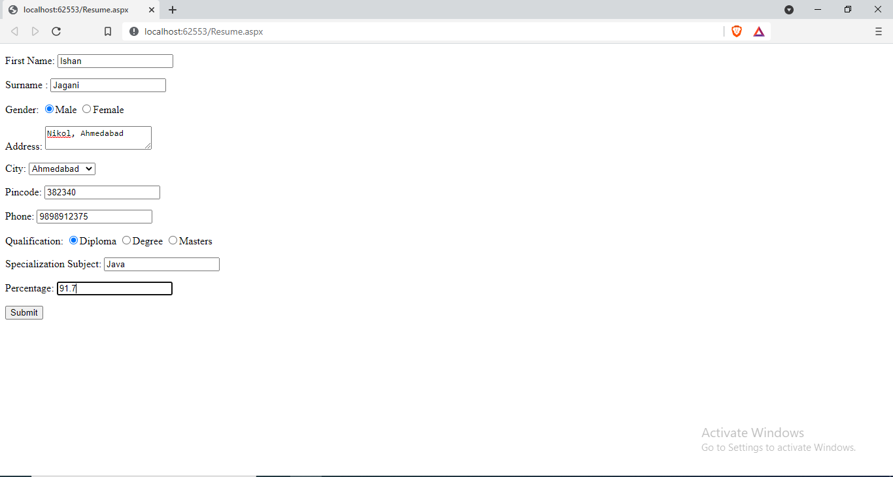

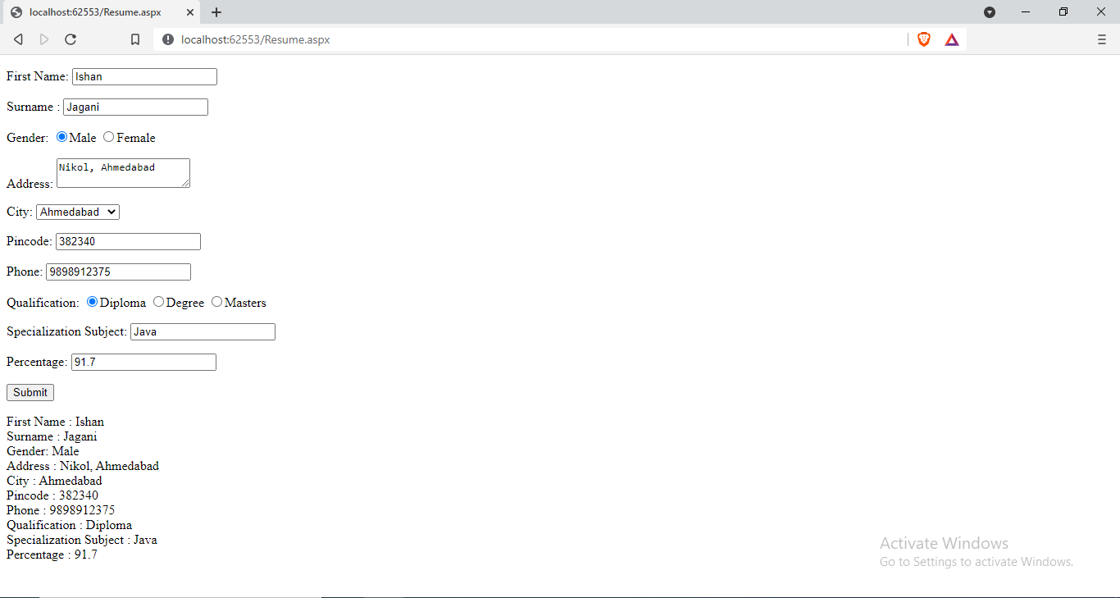

|  |  |  |  |
| --- | --- | --- | --- |
| Start Date | End/Sign Date | Faculty Sign | Remarks/Grade |
|  |  |  |  |

Practical : 5

#### **Aim : Create a web form where user enters following marks. ASP.NET, JAVA, ISS, Project (All out of 100). When user submits the marks, numeric value validation must be done. On entering marks, the grade should be displayed in message box .**

Result.aspx

<%@ Page Language="vb" AutoEventWireup="false" CodeBehind="WebForm1.aspx.vb" Inherits="Practical_5.WebForm1" %>

<!DOCTYPE html PUBLIC "-//W3C//DTD XHTML 1.0 Transitional//EN" "http://www.w3.org/TR/xhtml1/DTD/xhtml1-transitional.dtd">

<html xmlns="http://www.w3.org/1999/xhtml">

<head runat="server">

<title></title>

<style type="text/css">

.style1

{

width: 302px;

}

</style>

</head>

<body>

<form id="marksheetForm" runat="server">

<div>

<table style="width:100%;">

<tr>

<td class="style1">

Asp.net </td>

<td>

<asp:TextBox ID="txtAsp" runat="server"></asp:TextBox>

</td>

<td>

<asp:Label ID="lblASP" runat="server" Text=""></asp:Label>

</td>

</tr>

<tr>

<td class="style1">

Java</td>

<td>

<asp:TextBox ID="txtJava" runat="server"></asp:TextBox>

</td>

<td>

<asp:Label ID="lblJava" runat="server" Text=""></asp:Label>

</td>

</tr>

<tr>

<td class="style1">

ICN</td>

<td>

<asp:TextBox ID="txtIcn" runat="server"></asp:TextBox>

</td>

<td>

<asp:Label ID="lblIcn" runat="server" Text=""></asp:Label>

</td>

</tr>

<tr>

<td class="style1">

ENS</td>

<td>

<asp:TextBox ID="txtEns" runat="server"></asp:TextBox>

</td>

<td>

<asp:Label ID="lblEns" runat="server" Text=""></asp:Label>

</td>

</tr>

<tr>

<td></td>

<td>

<asp:Button ID="viewResultBtn" runat="server" Text="Submit" Width="126px" />

</td>

<td></td>

</tr>

</table>

</div>

</form>

</body>

</html>

Result.aspx.vb

Public Class WebForm1

Inherits System.Web.UI.Page

Protected Sub Page_Load(ByVal sender As Object, ByVal e As System.EventArgs) Handles Me.Load

End Sub

Private Function getMyGrade(ByVal p1 As String) As String

If p1 > 90 And p1 <= 100 Then

Return "AA"

ElseIf p1 > 80 And p1 <= 90 Then

Return "AB"

ElseIf p1 > 70 And p1 <= 80 Then

Return "BB"

ElseIf p1 > 60 And p1 <= 70 Then

Return "BC"

ElseIf p1 > 50 And p1 <= 60 Then

Return "CC"

ElseIf p1 > 40 And p1 <= 50 Then

Return "DD"

Else

Return "Fail"

End If

End Function

Protected Sub viewResultBtn_Click(ByVal sender As Object, ByVal e As EventArgs) Handles viewResultBtn.Click

lblASP.Text = getMyGrade(txtAsp.Text)

lblJava.Text = getMyGrade(txtJava.Text)

lblIcn.Text = getMyGrade(txtIcn.Text)

lblEns.Text = getMyGrade(txtEns.Text)

End Sub

End Class

Result :

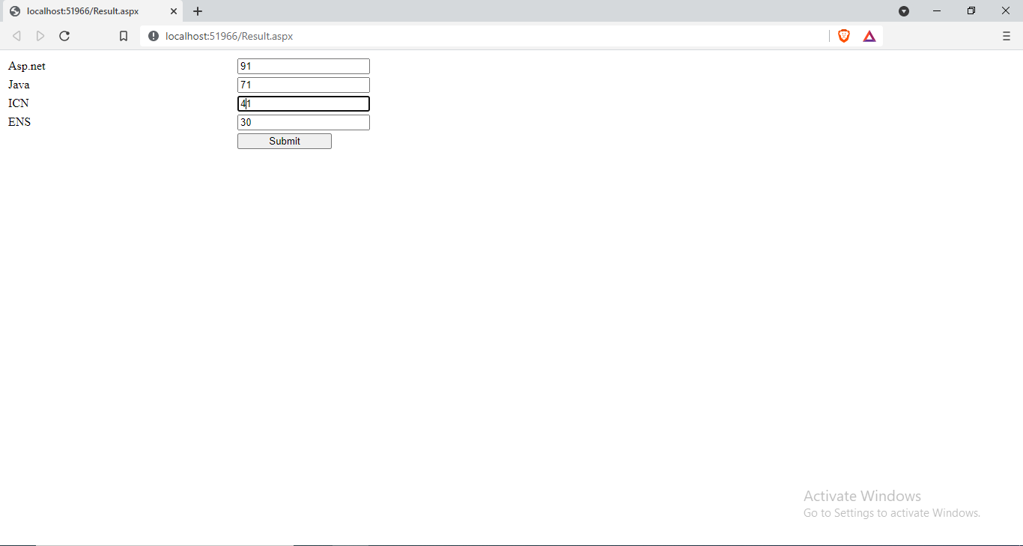

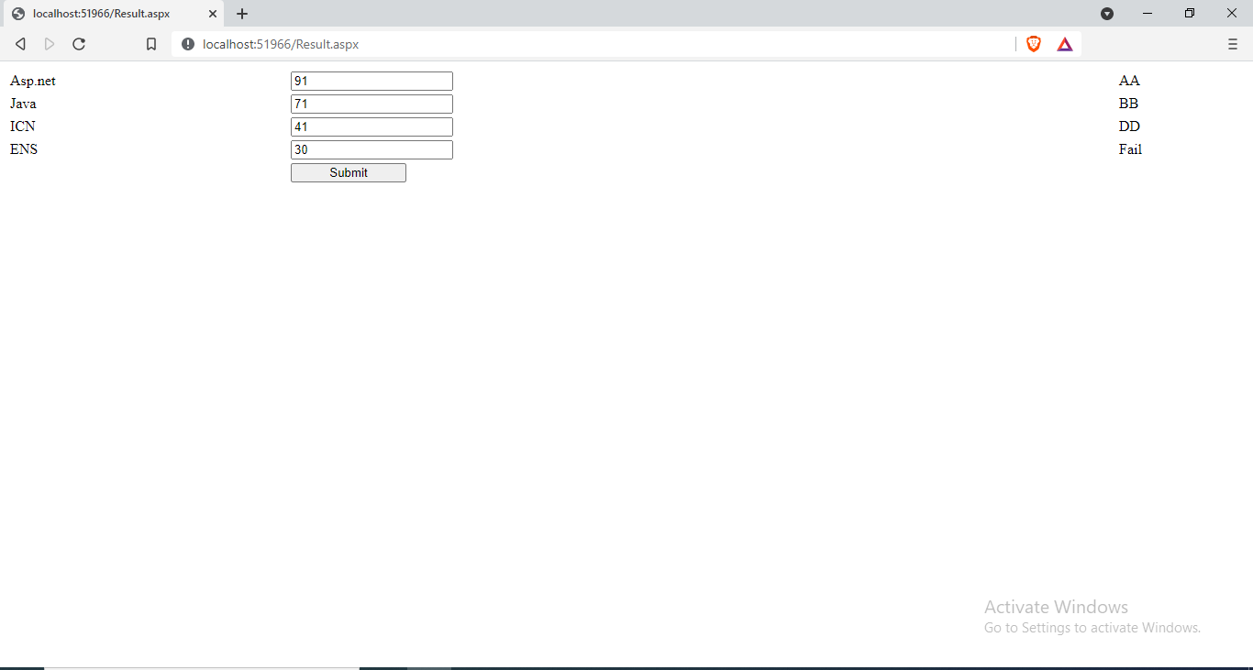

|  |  |  |  |
| --- | --- | --- | --- |
| Start Date | End/Sign Date | Faculty Sign | Remarks/Grade |
|  |  |  |  |

Practical: 6

#### **Aim : Create a Simple Calculator with Validation and Details**

Calculator.aspx

<%@ Page Language="vb" AutoEventWireup="false" CodeBehind="Calculator.aspx.vb" Inherits="Practical_06.Calculator" %>

<!DOCTYPE html PUBLIC "-//W3C//DTD XHTML 1.0 Transitional//EN" "http://www.w3.org/TR/xhtml1/DTD/xhtml1-transitional.dtd">

<html xmlns="http://www.w3.org/1999/xhtml">

<head runat="server">

<title></title>

</head>

<body>

<form id="form1" runat="server">

<div>

<asp:TextBox ID="tbA" runat="server" />

<asp:RequiredFieldValidator ID="rfvA" runat="server" ControlToValidate="tbA" ErrorMessage="Enter A" ForeColor="Red" />

<asp:RangeValidator ID="rnvA" runat="server" ControlToValidate="tbA" ErrorMessage="Invalid Value" Type="Double" MinimumValue="0.0" MaximumValue="65536.0" ForeColor="Red" />

<asp:TextBox ID="tbB" runat="server" />

<asp:RequiredFieldValidator ID="rfvB" runat="server" ControlToValidate="tbB" ErrorMessage="Enter B" ForeColor="Red" />

<asp:RangeValidator ID="rnvB" runat="server" ControlToValidate="tbB" ErrorMessage="Invalid Value" Type="Double" MinimumValue="0.0" MaximumValue="65536.0" ForeColor="Red" />

<asp:DropDownList ID="drpOp" runat="server">

<asp:ListItem>+</asp:ListItem>

<asp:ListItem>-</asp:ListItem>

<asp:ListItem>*</asp:ListItem>

<asp:ListItem>/</asp:ListItem>

<asp:ListItem>%</asp:ListItem>

</asp:DropDownList>

<asp:Button ID="btnCalculate" runat="server" Text="Calculate" />

<asp:Label ID="lblAnswer" runat="server" />

</div>

</form>

</body>

</html>

Calculator.aspx.vb

Public Class Calculator

Inherits System.Web.UI.Page

Protected Sub Page_Load(ByVal sender As Object, ByVal e As System.EventArgs) Handles Me.Load

End Sub

Protected Sub btnCalculate_Click(ByVal sender As Object, ByVal e As EventArgs) Handles btnCalculate.Click

If CInt(tbB.Text) = 0 Then

Response.Write("Cannot Divided by 0")

ElseIf drpOp.Text = "+" Then

lblAnswer.Text = CDbl(tbA.Text) + CDbl(tbB.Text)

ElseIf drpOp.Text = "-" Then

lblAnswer.Text = CDbl(tbA.Text) - CDbl(tbB.Text)

ElseIf drpOp.Text = "*" Then

lblAnswer.Text = CDbl(tbA.Text) * CDbl(tbB.Text)

ElseIf drpOp.Text = "/" Then

lblAnswer.Text = CDbl(tbA.Text) / CDbl(tbB.Text)

ElseIf drpOp.Text = "%" Then

lblAnswer.Text = CDbl(tbA.Text) Mod CDbl(tbB.Text)

End If

End Sub

End Class

Output :

Addition:



Subtraction:



Multiplication:



Division:



Modulo:



Errors :

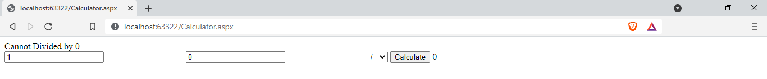



|  |  |  |  |
| --- | --- | --- | --- |
| Start Date | End/Sign Date | Faculty Sign | Remarks/Grade |
|  |  |  |  |

Practical – 7

##### **Aim : Create a web page using the concept of cascading style sheets in ASP.NET.**

CSSDemo.aspx

<%@ Page Language="vb" AutoEventWireup="false" CodeBehind="CSSDemo.aspx.vb" Inherits="Practical_07.WebForm1" %>

<!DOCTYPE html PUBLIC "-//W3C//DTD XHTML 1.0 Transitional//EN" "http://www.w3.org/TR/xhtml1/DTD/xhtml1-transitional.dtd">

<html xmlns="http://www.w3.org/1999/xhtml">

<head runat="server">

<title>CSS Declaration Demo</title>

<link rel="Stylesheet" type="text/css" href="CSSDemo.css" />

<style type="text/css">

h1

{

color:Lime;

}

</style>

</head>

<body>

<form id="form1" runat="server">

<div>

<input type="text" style="background-color:Purple;border:2px solid white;" placeholder="inline CSS" />

<h1> Internal CSS </h1>

</div>

</form>

</body>

</html>

CSSDemo.css

body

{

background-color: Gray;

}

div

{

background-color: Red;

}

Output :

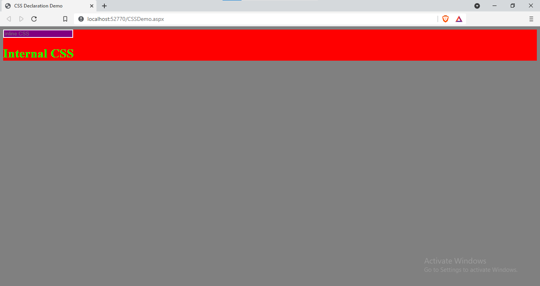

|  |  |  |  |
| --- | --- | --- | --- |
| Start Date | End/Sign Date | Faculty Sign | Remarks/Grade |
|  |  |  |  |

Practical – 8

##### **Aim : Create a web page using the concept of Theme & Skin in ASP.NET.**

ThemeAndSkin.aspx

<%@ Page Theme="MyTheme" Language="vb" AutoEventWireup="false" CodeBehind="ThemeAndSkin.aspx.vb" Inherits="Practical_08.ThemeAndSkin" %>

<!DOCTYPE html PUBLIC "-//W3C//DTD XHTML 1.0 Transitional//EN" "http://www.w3.org/TR/xhtml1/DTD/xhtml1-transitional.dtd">

<html xmlns="http://www.w3.org/1999/xhtml">

<head runat="server">

<title></title>

</head>

<body>

<form id="form1" runat="server">

<p>

<asp:TextBox ID="TextBox1" runat="server"></asp:TextBox>

</p>

<p>

<asp:TextBox ID="TextBox2" runat="server"></asp:TextBox>

</p>

<asp:RadioButton ID="RadioButton1" GroupName="bool" runat="server" Text="Yes" />

<asp:RadioButton ID="RadioButton2" GroupName="bool" runat="server" Text="No" />

<br />

<asp:Button ID="Button1" runat="server" Text="Button" />

</form>

</body>

</html>

Controls.skin

<asp:TextBox runat="server" BackColor="Black" ForeColor="White" />

<asp:RadioButton runat="server" ForeColor="Purple" />

<asp:Button runat="server" BackColor="Black" ForeColor="Cyan" />

Output:

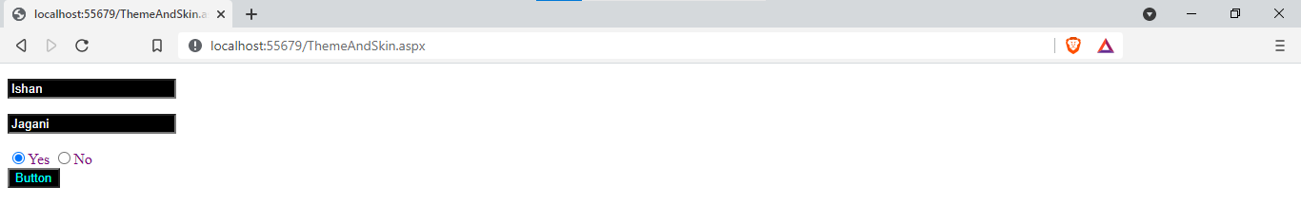

|  |  |  |  |
| --- | --- | --- | --- |
| Start Date | End/Sign Date | Faculty Sign | Remarks/Grade |
|  |  |  |  |

Practical : 9

##### **Aim : Create Home page of your website using master page concept.**

HeaderFooter.Master

<%@ Master Language="VB" AutoEventWireup="false" CodeBehind="HeaderFooter.master.vb" Inherits="Practical_09.HeaderFooter" %>

<!DOCTYPE html PUBLIC "-//W3C//DTD XHTML 1.0 Transitional//EN" "http://www.w3.org/TR/xhtml1/DTD/xhtml1-transitional.dtd">

<html xmlns="http://www.w3.org/1999/xhtml">

<head id="Head1" runat="server">

<title>Milk Prism</title>

<style type="text/css">

#header{

color: #247BA0;

text-align: center;

font-size: 20px;

}

#nav{

background-color:Blue;

padding: 5px;

}

li a {

color: #F1FAEE;

font-size: 30px;

column-width: 5%;

}

li

{

display: inline;

padding-left: 2px;

column-width: 20px;

}

a{

text-decoration: none;

margin-left:20px

}

li a:hover{

background-color: #F3FFBD;

color: #FF1654;

padding:1%;

}

#footer{

background-color: #C7EFCF;

text-align:center;

padding-bottom: 5%;

font-size: 20px;

}

#con{

border:double;

border-color:Fuchsia;

}

</style>

<asp:ContentPlaceHolder ID="head" runat="server">

</asp:ContentPlaceHolder>

</head>

<!DOCTYPE html>

<body>

<header id="header">

<h1>MilkPrism</h1>

</header>

<nav id="nav">

<ul>

<li><a href="home.aspx">Find Us</a></li>

<li><a href="#">Contact Us</a></li>

<li><a href="#">Login</a></li>

<li><a href="#">Sign Up</a></li>

</ul>

</nav>

<div id="con">

<asp:ContentPlaceHolder ID="ContentPlaceHolder1" runat="server">

</asp:ContentPlaceHolder>

</div>

<footer id="footer">

insta : milkprism

fb : milkprism

</footer>

</body>

</html>

Home.aspx

<%@ Page Title="" Language="vb" AutoEventWireup="false" MasterPageFile="~/HeaderFooter.Master" CodeBehind="Home.aspx.vb" Inherits="Practical_09.Home" %>

<asp:Content ID="Content1" ContentPlaceHolderID="head" runat="server">

</asp:Content>

<asp:Content ID="Content2" ContentPlaceHolderID="ContentPlaceHolder1" runat="server">

<h1>Home Page</h1>

</asp:Content>

Output :

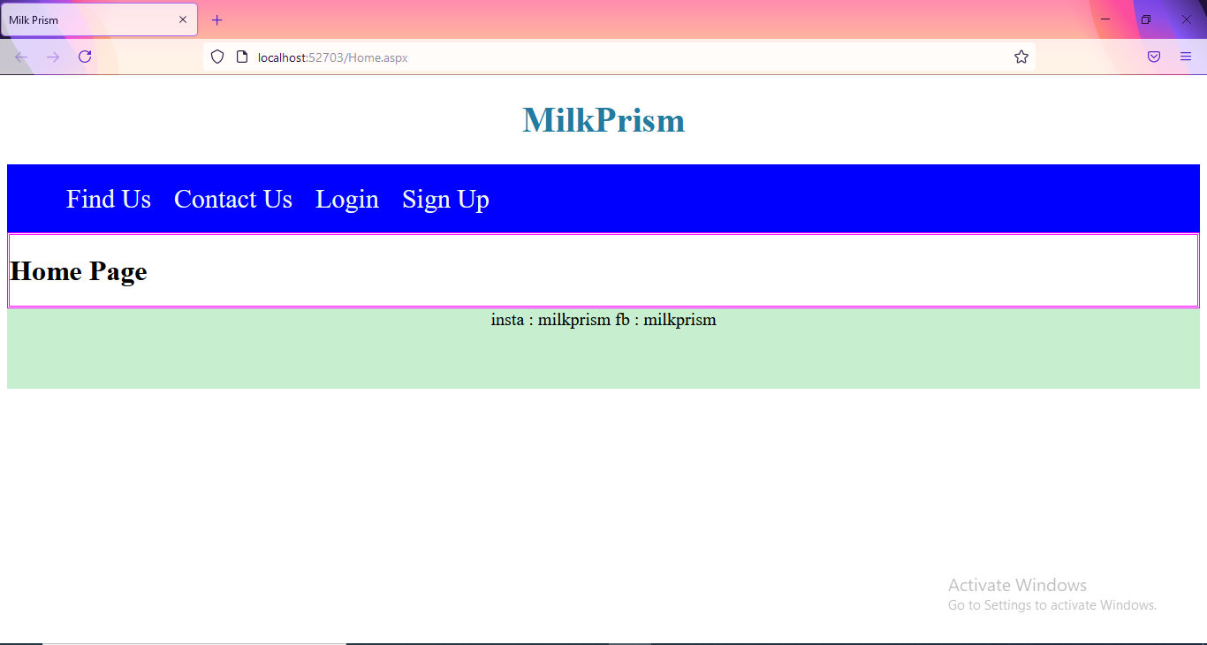

|  |  |  |  |
| --- | --- | --- | --- |
| Start Date | End/Sign Date | Faculty Sign | Remarks/Grade |
|  |  |  |  |

Practical : 10

##### **Aim : Create a simple web application to illustrate the concept of nesting master page in ASP.NET.**

Master.Master

<%@ Master Language="VB" AutoEventWireup="false" CodeBehind="Master.master.vb" Inherits="Practical_10.Master" %>

<!DOCTYPE html PUBLIC "-//W3C//DTD XHTML 1.0 Transitional//EN" "http://www.w3.org/TR/xhtml1/DTD/xhtml1-transitional.dtd">

<html xmlns="http://www.w3.org/1999/xhtml">

<head runat="server">

<title></title>

<asp:ContentPlaceHolder ID="head" runat="server">

</asp:ContentPlaceHolder>

</head>

<body>

<form id="form1" runat="server">

<div>

<table cellpadding="50px" style="border:3px Solid Red;">

<tr>

<td colspan="2" align="center">

Header Part

</td>

</tr>

<tr>

<td width="20%" colspan="2">

&nbsp<asp:ContentPlaceHolder ID="ContentPlaceHolder1" runat="server">

</asp:ContentPlaceHolder>

</td>

</tr>

<tr>

<td colspan="2" align="center">

Footer Part

</td>

</tr>

</table>

</div>

</form>

</body>

</html>

SideBar.master

<%@ Master Language="VB" MasterPageFile="~/Master.Master" AutoEventWireup="false" CodeBehind="SideBar.master.vb" Inherits="Practical_10.SideBar" %>

<asp:Content ID="Content1" ContentPlaceHolderID="head" runat="server">

</asp:Content>

<asp:Content ID="Content2" ContentPlaceHolderID="ContentPlaceHolder1" runat="server">

<table width="60%" style="border:2px dotted blue;">

<tr>

<td width="40%">Sidebar</td>

<td><asp:ContentPlaceHolder ID="cph" runat="server"></asp:ContentPlaceHolder></td>

</tr>

</table>

</asp:Content>

Shops.aspx

<%@ Page Title="" Language="vb" AutoEventWireup="false" MasterPageFile="~/SideBar.master" CodeBehind="Shops.aspx.vb" Inherits="Practical_10.Shops" %>

<asp:Content ID="Content1" ContentPlaceHolderID="cph" runat="server">

Krishna Dairy

<br />

Kandhenu Dairy

<br />

Amul

<br />

Sumul

<br />

Havemor Eatery

</asp:Content>

Output :

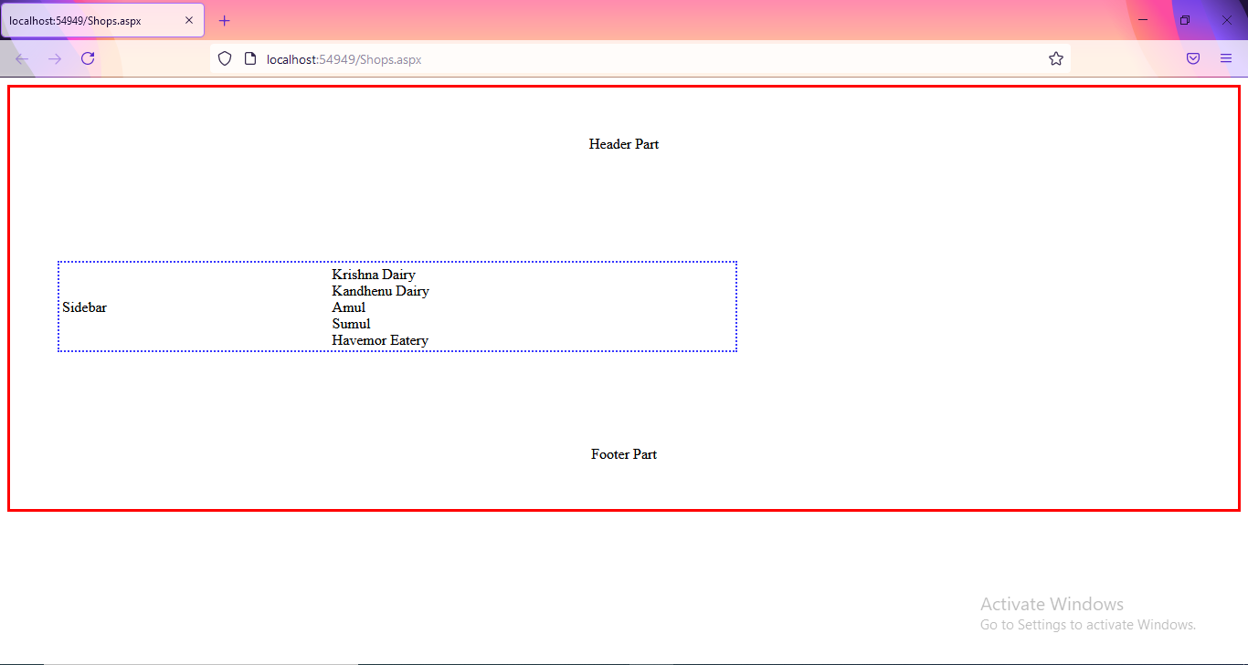

|  |  |  |  |
| --- | --- | --- | --- |
| Start Date | End/Sign Date | Faculty Sign | Remarks/Grade |
|  |  |  |  |

Practical : 11

##### **Aim: Develop a web page to implement the concept of state management using Cookies.**

WebForm1.aspx

<%@ Page Language="vb" AutoEventWireup="false" CodeBehind="WebForm1.aspx.vb" Inherits="Practical_11.WebForm1" %>

<!DOCTYPE html PUBLIC "-//W3C//DTD XHTML 1.0 Transitional//EN" "http://www.w3.org/TR/xhtml1/DTD/xhtml1-transitional.dtd">

<html xmlns="http://www.w3.org/1999/xhtml">

<head runat="server">

<title></title>

</head>

<body>

<form id="form1" runat="server">

<div>

<asp:Button ID="btn1" runat="server" Text="Write to Cookies" />

</div>

</form>

</body>

</html>

WebForm1.aspx.vb

Public Class WebForm1

Inherits System.Web.UI.Page

Protected Sub Page_Load(ByVal sender As Object, ByVal e As System.EventArgs) Handles Me.Load

End Sub

Protected Sub btn1_Click(ByVal sender As Object, ByVal e As EventArgs) Handles btn1.Click

Dim ck As New HttpCookie("MyCookie")

ck.Values.Add("Username", "Ishan")

ck.Expires = Now.AddMonths(2)

Response.Cookies.Add(ck)

Response.Redirect("WebForm2.aspx")

End Sub

End Class

WebForm2.aspx.vb

Public Class WebForm2

Inherits System.Web.UI.Page

Protected Sub Page_Load(ByVal sender As Object, ByVal e As System.EventArgs) Handles Me.Load

Response.Write("Welcome " & Request.Cookies("myCookie").Values("Username"))

End Sub

End Class

Output :

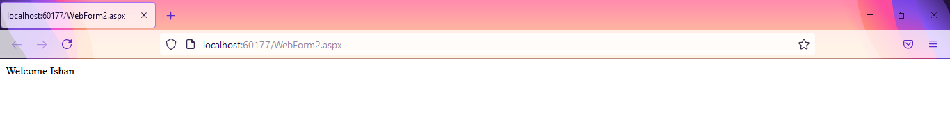

|  |  |  |  |
| --- | --- | --- | --- |
| Start Date | End/Sign Date | Faculty Sign | Remarks/Grade |
|  |  |  |  |

Practical : 12

##### **Aim: Develop a web page to implement the concept of state management using Session and Application.**

First.aspx

<%@ Page Language="vb" AutoEventWireup="false" CodeBehind="First.aspx.vb" Inherits="Practical_12.First" %>

<!DOCTYPE html PUBLIC "-//W3C//DTD XHTML 1.0 Transitional//EN" "http://www.w3.org/TR/xhtml1/DTD/xhtml1-transitional.dtd">

<html xmlns="http://www.w3.org/1999/xhtml">

<head runat="server">

<title></title>

</head>

<body>

<form id="form1" runat="server">

<div>

<asp:TextBox ID="tb1" runat="server"></asp:TextBox>

<asp:Button ID="Button1" runat="server" Text="Login" />

</div>

</form>

</body>

</html>

First.aspx.vb

Public Class First

Inherits System.Web.UI.Page

Protected Sub Page_Load(ByVal sender As Object, ByVal e As System.EventArgs) Handles Me.Load

End Sub

Protected Sub Button1_Click(ByVal sender As Object, ByVal e As EventArgs) Handles Button1.Click

Session("username") = tb1.Text

Application("lastuser") = tb1.Text

Response.Redirect("Second.aspx")

End Sub

End Class

Second.aspx.vb

Public Class Second

Inherits System.Web.UI.Page

Protected Sub Page_Load(ByVal sender As Object, ByVal e As System.EventArgs) Handles Me.Load

Response.Write("Welcome : " & Session("username"))

Response.Write("<br />Last Logged User : " & Application("lastuser"))

End Sub

End Class

Output :



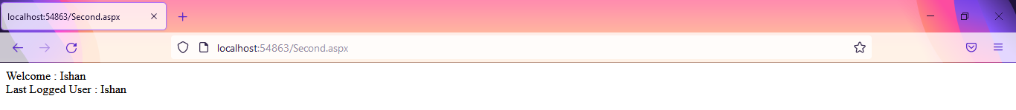

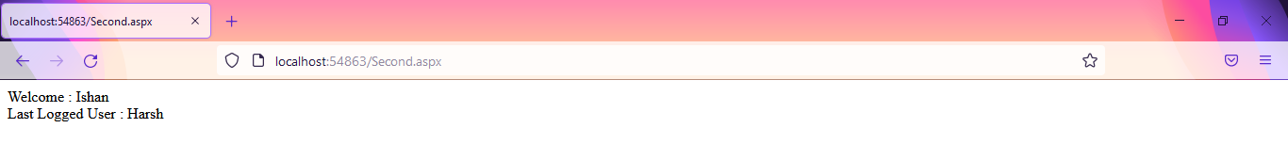

|  |  |  |  |
| --- | --- | --- | --- |
| Start Date | End/sign Date | Faculty Sign | Remarks/Grade |
|  |  |  |  |

Practical : 13

##### **Aim: Develop a web page to implement the concept of state management using ViewState and QueryString.**

First.aspx

<%@ Page Language="vb" AutoEventWireup="false" CodeBehind="First.aspx.vb" Inherits="Practical_13.First" %>

<!DOCTYPE html PUBLIC "-//W3C//DTD XHTML 1.0 Transitional//EN" "http://www.w3.org/TR/xhtml1/DTD/xhtml1-transitional.dtd">

<html xmlns="http://www.w3.org/1999/xhtml">

<head runat="server">

<title></title>

</head>

<body>

<form id="form1" runat="server">

<div>

First Name

<asp:TextBox ID="tb1" runat="server" />

&nbsp;

Last Name

<asp:TextBox ID="tb2" runat="server" />

<br />

<br />

<asp:Button ID="btn" runat="server" Text="Click Me" />

<br />

<a href="Second.aspx?word1=abcd...&word2=xyz">Click Here</a>

<br />

<asp:HyperLink ID="hl1" runat="server" NavigateUrl="~/Second.aspx?word1=Baburao&word2=Apte" Text="FullName Here" />

</div>

</form>

</body>

</html>

First.aspx.vb

Public Class First

Inherits System.Web.UI.Page

Protected Sub Page_Load(ByVal sender As Object, ByVal e As System.EventArgs) Handles Me.Load

End Sub

Protected Sub btn_Click(ByVal sender As Object, ByVal e As EventArgs) Handles btn.Click

Response.Redirect("Second.aspx?word1=" & tb1.Text & "&word2=" & tb2.Text)

End Sub

End Class

Second.aspx

<%@ Page Language="vb" AutoEventWireup="false" CodeBehind="Second.aspx.vb" Inherits="Practical_13.Second" %>

<!DOCTYPE html PUBLIC "-//W3C//DTD XHTML 1.0 Transitional//EN" "http://www.w3.org/TR/xhtml1/DTD/xhtml1-transitional.dtd">

<html xmlns="http://www.w3.org/1999/xhtml">

<head runat="server">

<title></title>

</head>

<body>

<form id="form1" runat="server">

<div>

Welcome To Home Page.

</div>

</form>

</body>

</html>

Second.aspx.vb

Public Class Second

Inherits System.Web.UI.Page

Protected Sub Page_Load(ByVal sender As Object, ByVal e As System.EventArgs) Handles Me.Load

Response.Write("Welcome, " & Request.QueryString("word1"))

Response.Write(" " & Request.QueryString("word2"))

End Sub

End Class

Output :

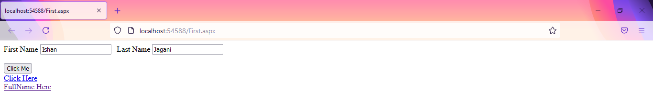

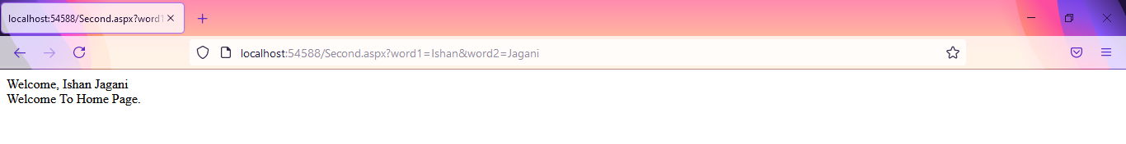

Using a tag :

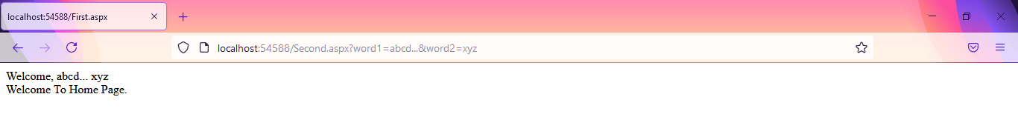

Using HyperLink tag :

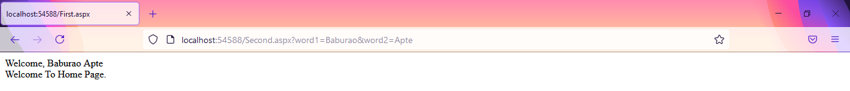

|  |  |  |  |
| --- | --- | --- | --- |
| Start Date | End/Sign Date | Faculty Sign | Remarks/Grade |
|  |  |  |  |

Practical : 14

##### **Aim: Create a web application using Global.asax file which will count the number of visitors on web page.**

Home.aspx

<%@ Page Language="vb" AutoEventWireup="false" CodeBehind="Home.aspx.vb" Inherits="Practical_14.Home" %>

<!DOCTYPE html PUBLIC "-//W3C//DTD XHTML 1.0 Transitional//EN" "http://www.w3.org/TR/xhtml1/DTD/xhtml1-transitional.dtd">

<html xmlns="http://www.w3.org/1999/xhtml">

<head runat="server">

<title></title>

</head>

<body>

<form id="form1" runat="server">

<div>

</div>

</form>

</body>

</html>

Home.aspx.vb

Public Class Home

Inherits System.Web.UI.Page

Protected Sub Page_Load(ByVal sender As Object, ByVal e As System.EventArgs) Handles Me.Load

Session.Timeout = 1

Response.Write("Total Visitors : " & Application("visitor"))

Response.Write("<br />Total Online : " & Application("online"))

End Sub

End Class

Global.asax.vb

Imports System.Web.SessionState

Public Class Global_asax

Inherits System.Web.HttpApplication

Sub Application_Start(ByVal sender As Object, ByVal e As EventArgs)

Application("visitor") = 0

Application("online") = 0

End Sub

Sub Session_Start(ByVal sender As Object, ByVal e As EventArgs)

Application("visitor") += 1

Application("online") += 1

End Sub

Sub Application_BeginRequest(ByVal sender As Object, ByVal e As EventArgs)

End Sub

Sub Application_AuthenticateRequest(ByVal sender As Object, ByVal e As EventArgs)

End Sub

Sub Application_Error(ByVal sender As Object, ByVal e As EventArgs)

End Sub

Sub Session_End(ByVal sender As Object, ByVal e As EventArgs)

Application("online") -= 1

End Sub

Sub Application_End(ByVal sender As Object, ByVal e As EventArgs)

End Sub

End Class

Output :

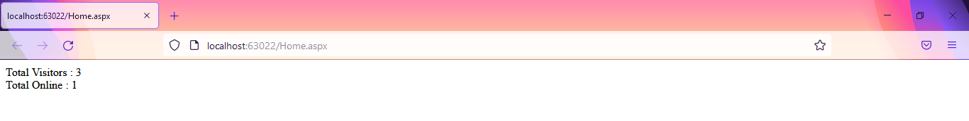

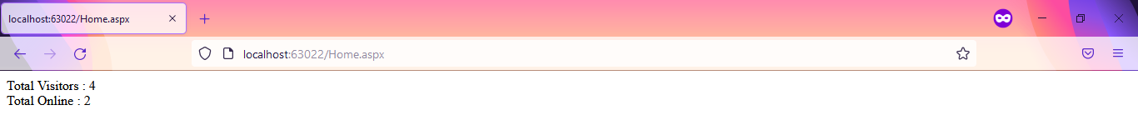

|  |  |  |  |
| --- | --- | --- | --- |
| Start Date | End/sign Date | Faculty Sign | Remarks/Grade |
|  |  |  |  |

Practical : 15

##### **Aim: Use various tags in Web.config file for ASP.NET configuration.**

Home.aspx

<%@ Page Language="vb" AutoEventWireup="false" CodeBehind="Home.aspx.vb" Inherits="Practical_15.Home" %>

<!DOCTYPE html PUBLIC "-//W3C//DTD XHTML 1.0 Transitional//EN" "http://www.w3.org/TR/xhtml1/DTD/xhtml1-transitional.dtd">

<html xmlns="http://www.w3.org/1999/xhtml">

<head runat="server">

<title></title>

</head>

<body>

<form id="form1" runat="server">

<div>

<asp:TextBox ID="TextBox1" runat="server"></asp:TextBox>

</div>

</form>

</body>

</html>

Home.aspx.vb

Public Class Home

Inherits System.Web.UI.Page

Protected Sub Page_Load(ByVal sender As Object, ByVal e As System.EventArgs) Handles Me.Load

Response.Write(ConfigurationManager.AppSettings("Title"))

Response.Write("</br>Website Version : " & ConfigurationManager.AppSettings("Version"))

End Sub

End Class

Web.config

<?xml version="1.0"?>

<configuration>

<system.web>

<pages theme="Green" />

<compilation debug="true" strict="false" explicit="true" targetFramework="4.0" />

</system.web>

<appSettings>

<add key="Version" value="3.2.0"/>

<add key="Title" value="My Name is Ishan"/>

</appSettings>

</configuration>

Green.skin

<asp:TextBox runat="server" BackColor="Green" ForeColor="White" />

Output :

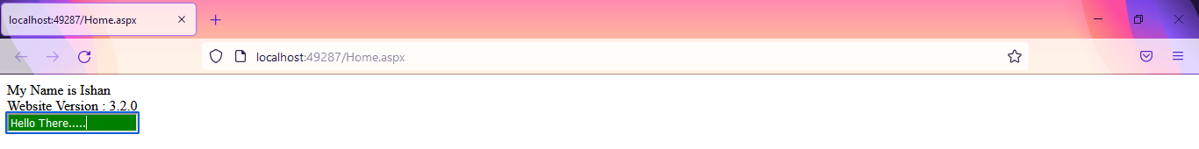

|  |  |  |  |
| --- | --- | --- | --- |
| Start Date | End/Sign Date | Faculty Sign | Remarks/Grade |
|  |  |  |  |

Practical : 16

##### **Aim: Write sample application to connect to database (connection object), Fetching and inserting data from database (command object) and using Data Reader.**

First.aspx

<%@ Page Language="vb" AutoEventWireup="false" CodeBehind="First.aspx.vb" Inherits="Practical_16.First" %>

<!DOCTYPE html>

<html xmlns="http://www.w3.org/1999/xhtml">

<head runat="server">

<title></title>

</head>

<body>

<form id="form1" runat="server">

<div>

<asp:Button ID="btnFetch" runat="server" Text="Fetch Data" />

<asp:Button ID="btnInsert" runat="server" Text="Insert Random Data" />

<br />

<asp:DropDownList ID="drpFetch" runat="server" AutoPostBack="true" />

</div>

</form>

</body>

</html>

First.aspx.vb

Public Class First

Inherits System.Web.UI.Page

Protected Sub Page_Load(ByVal sender As Object, ByVal e As System.EventArgs) Handles Me.Load

End Sub

Protected Sub btnFetch_Click(sender As Object, e As EventArgs) Handles btnFetch.Click

Dim con As New SqlClient.SqlConnection("Data Source=(LocalDB)\MSSQLLocalDB;AttachDbFilename=C:\Users\ISHAN\Desktop\Databases\Students.mdf;Integrated Security=True;Connect Timeout=30")

Dim cmd As New SqlClient.SqlCommand("select Area from students", con)

Dim dr As SqlClient.SqlDataReader

con.Open()

dr = cmd.ExecuteReader()

While dr.Read()

drpFetch.Items.Add(dr.Item(0))

'Response.Write(dr("ID") & dr(1) & dr(2) & "</br>")

End While

con.Close()

End Sub

Protected Sub btnInsert_Click(sender As Object, e As EventArgs) Handles btnInsert.Click

Dim fname As String

Dim lname As String

Dim Area As String

Dim Position As String

fname = "Bhole"

lname = "Bhandari"

Area = "Himalayas"

Position = "God"

Dim con As New SqlClient.SqlConnection("Data Source=(LocalDB)\MSSQLLocalDB;AttachDbFilename=C:\Users\ISHAN\Desktop\Databases\Students.mdf;Integrated Security=True;Connect Timeout=30")

Dim cmd As New SqlClient.SqlCommand("insert into students values('" & 4 & "','" & fname & "','" & lname & "','" & Area & "','" & Position & "')", con)

con.Open()

cmd.ExecuteNonQuery()

con.Close()

Response.Write("Random Data Inserted Successfully")

con.Open()

End Sub

End Class

Output :

Dummy Data in Database :

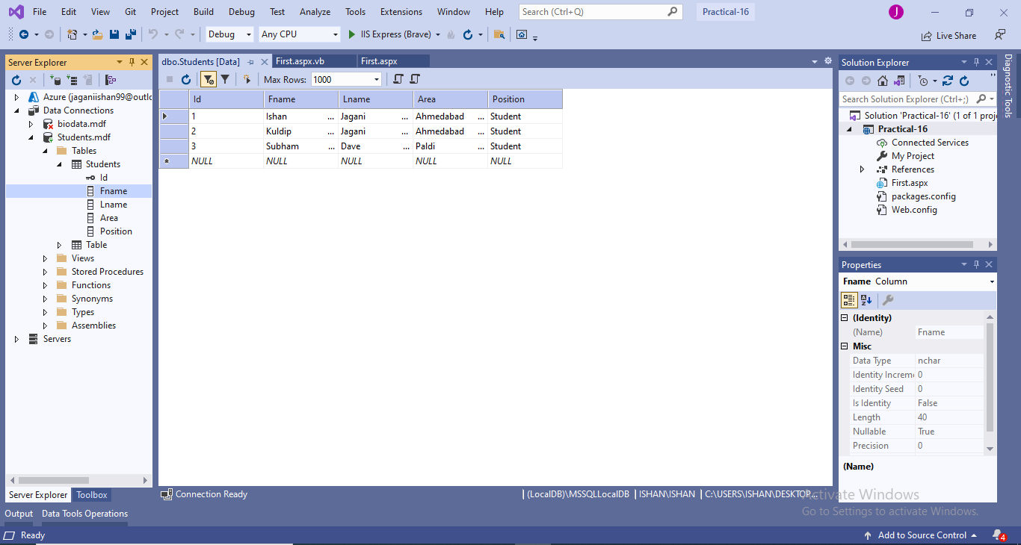

Fetching Data From Database into DropDownList :

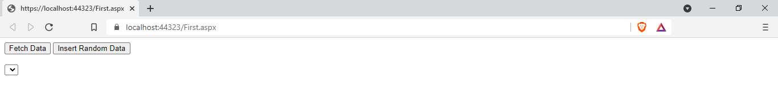

After Fetching :

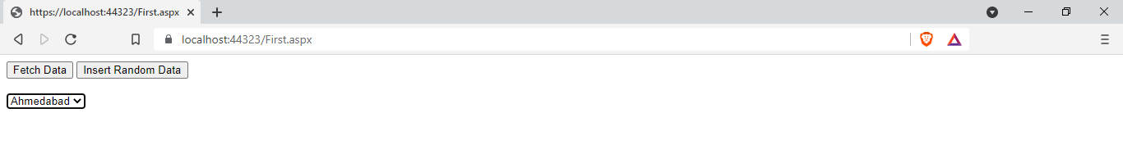

Inserting Data Into Database :

Before Inserting:

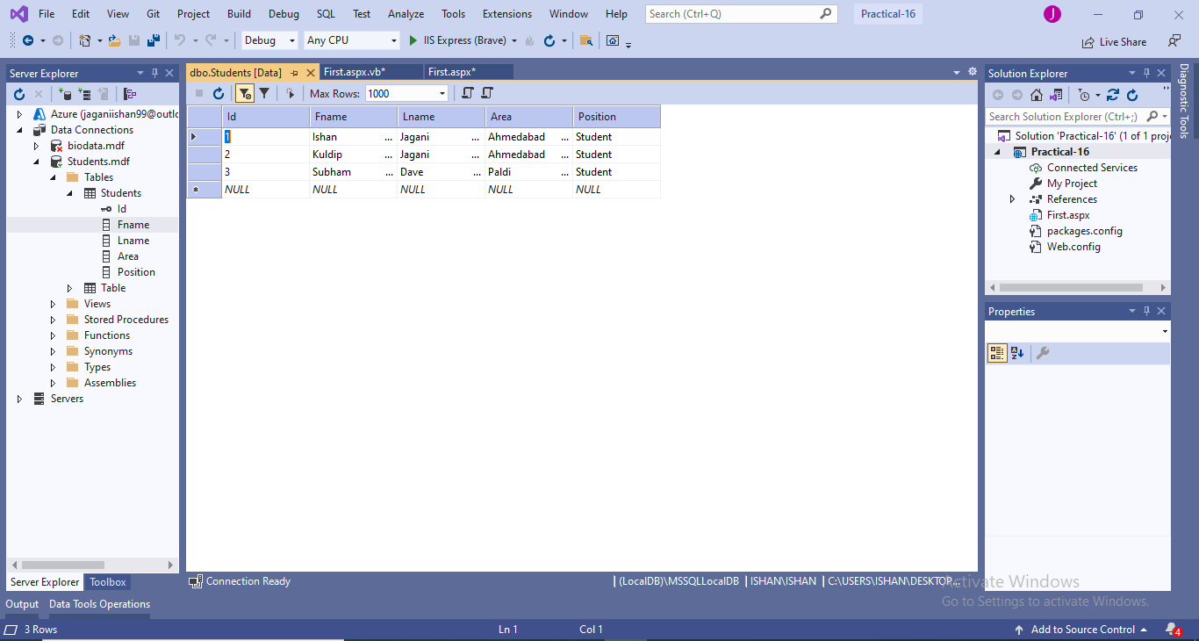

Inserted Data :

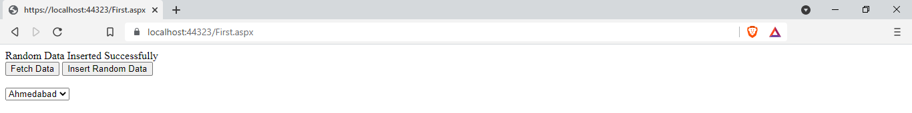

After Inserting Data :

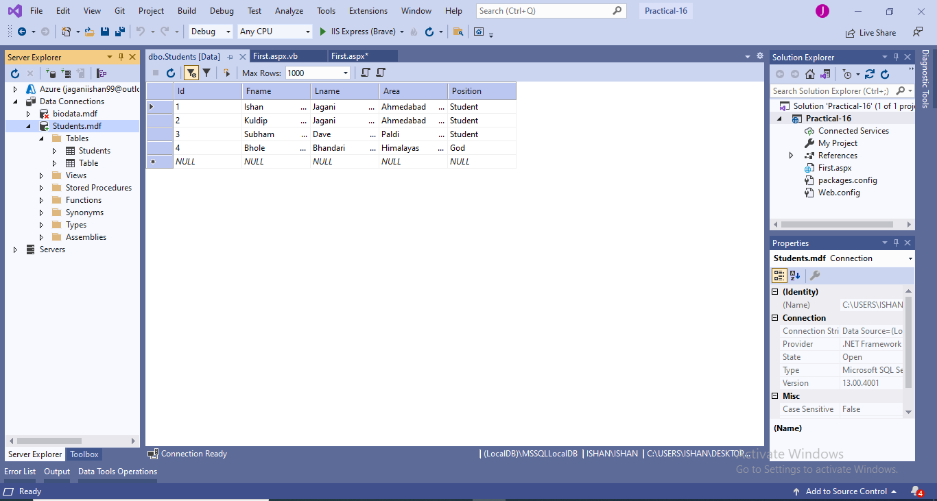

|  |  |  |  |
| --- | --- | --- | --- |
| Start Date | End/Sign Date | Faculty Sign | Remarks/Grade |
|  |  |  |  |

Practical : 17

##### **Aim: Create a Web page and test the connectivity of your database with biodata form in exercise 1. If connected, display the message that connection with database is successful, and redirect the user to his homepage**

First.aspx

<%@ Page Language="vb" AutoEventWireup="false" CodeBehind="First.aspx.vb" Inherits="Practical_17.First" %>

<!DOCTYPE html>

<html xmlns="http://www.w3.org/1999/xhtml">

<head runat="server">

<title></title>

</head>

<body>

<form id="form1" runat="server">

<div>

Name :

<asp:TextBox ID="txtName" runat="server" />

<br />

Enrollment :

<asp:TextBox ID="txtEnroll" runat="server" MaxLength="12" />

<br />

Password :

<asp:TextBox ID="txtPwd" runat="server" TextMode="Password" />

<br />

<asp:Button ID="submit" runat="server" Text="Submit" />

</div>

</form>

</body>

</html>

First.aspx.vb

Public Class First

Inherits System.Web.UI.Page

Protected Sub Page_Load(ByVal sender As Object, ByVal e As System.EventArgs) Handles Me.Load

End Sub

Protected Sub submit_Click(sender As Object, e As EventArgs) Handles submit.Click

Dim conCheck As String

Try

Dim con As New SqlClient.SqlConnection("Data Source=(LocalDB)\MSSQLLocalDB;AttachDbFilename=C:\Users\ISHAN\Desktop\First.mdf;Integrated Security=True;Connect Timeout=30")

con.Open()

conCheck = con.State = ConnectionState.Open

Catch ex As Exception

Response.Write("Connection Unsuccessful")

End Try

If conCheck = True Then

Response.Redirect("Home.aspx")

End If

End Sub

End Class

Home.aspx

<%@ Page Language="vb" AutoEventWireup="false" CodeBehind="Home.aspx.vb" Inherits="Practical_17.Home" %>

<!DOCTYPE html>

<html xmlns="http://www.w3.org/1999/xhtml">

<head runat="server">

<title></title>

</head>

<body>

<form id="form1" runat="server">

<div>

<asp:Label ID="lblGreet" runat="server" Text="Your Connection was Successful and You are Redirected to the Home Page" />

</div>

</form>

</body>

</html>

Database:

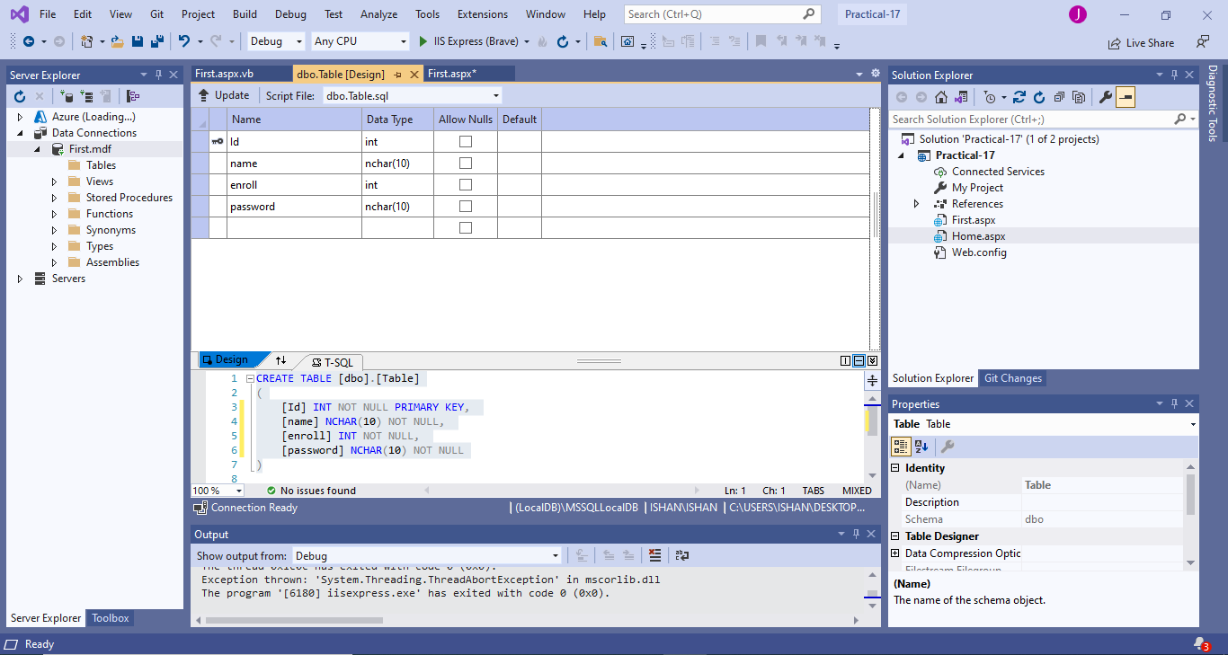

Output :

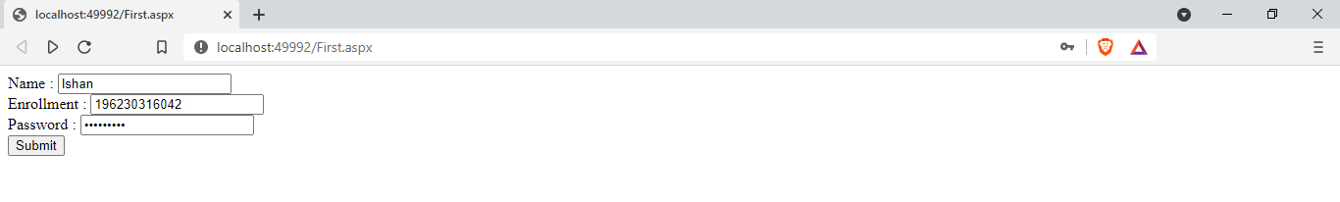

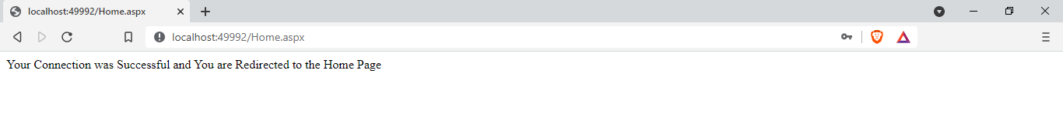

|  |  |  |  |
| --- | --- | --- | --- |
| Start Date | End/Sign Date | Faculty Sign | Remarks/Grade |
|  |  |  |  |

Practical : 18

##### **Aim: Create a login page in your web application. Login page must have user name and password fields. If user enters correct ID, Password, he must be redirected to the homepage of your website.**

Login.aspx

<%@ Page Language="vb" AutoEventWireup="false" CodeBehind="Login.aspx.vb" Inherits="Practical_18.Login" %>

<!DOCTYPE html>

<html xmlns="http://www.w3.org/1999/xhtml">

<head runat="server">

<title></title>

</head>

<body>

<form id="form1" runat="server">

<div>

Username :

<asp:TextBox ID="txtUname" runat="server" />

<br />

<br />

Password :

<asp:TextBox ID="txtPwd" runat="server" TextMode="Password" />

<br />

<br />

<asp:Button ID="login" runat="server" Text="Login" OnClick="Login_Click" />

</div>

</form>

</body>

</html>

Login.aspx.vb

Imports System.Data.SqlClient

Public Class Login

Inherits System.Web.UI.Page

Protected Sub Page_Load(ByVal sender As Object, ByVal e As System.EventArgs) Handles Me.Load

End Sub

Protected Sub Login_Click(sender As Object, e As EventArgs) Handles login.Click

Dim con As New SqlClient.SqlConnection("Data Source=(LocalDB)\MSSQLLocalDB;AttachDbFilename=C:\Users\ISHAN\Desktop\students.mdf;Integrated Security=True;Connect Timeout=30")

Dim cmd As New SqlClient.SqlCommand("Select * from students where username = '" & txtUname.Text & "' and password= '" & txtPwd.Text & "'", con)

Dim ad As New SqlDataAdapter(cmd)

Dim ds As New DataSet

con.Open()

ad.Fill(ds)

con.Close()

If ds.Tables(0).Rows.Count > 0 Then

Response.Redirect("Home.aspx")

Else

Response.Write("Invalid Username or Password")

End If

End Sub

End Class

Home.aspx

<%@ Page Language="vb" AutoEventWireup="false" CodeBehind="Home.aspx.vb" Inherits="Practical_18.Home" %>

<!DOCTYPE html>

<html xmlns="http://www.w3.org/1999/xhtml">

<head runat="server">

<title></title>

</head>

<body>

<form id="form1" runat="server">

<div>

Login Was Successful and you are Redirected to Home Page

</div>

</form>

</body>

</html>

Database :

Database Format :

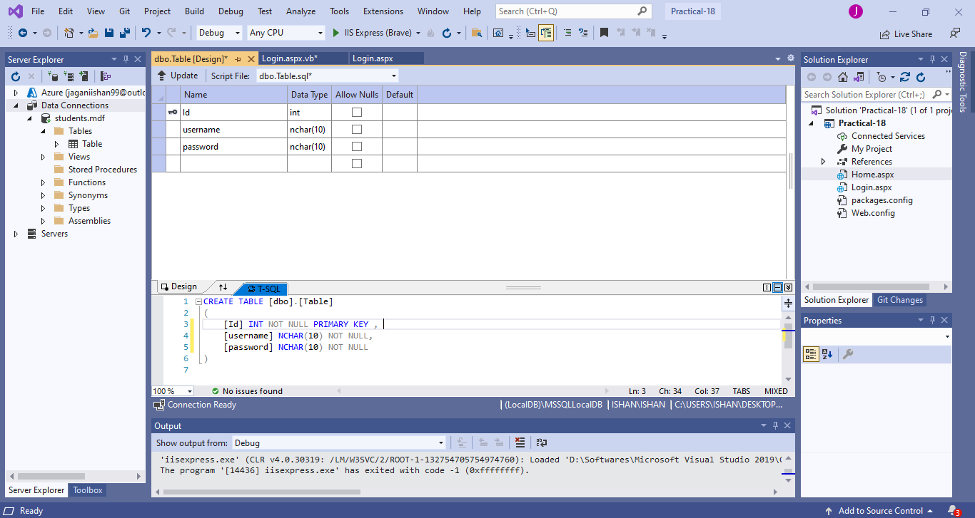

Records in Database :

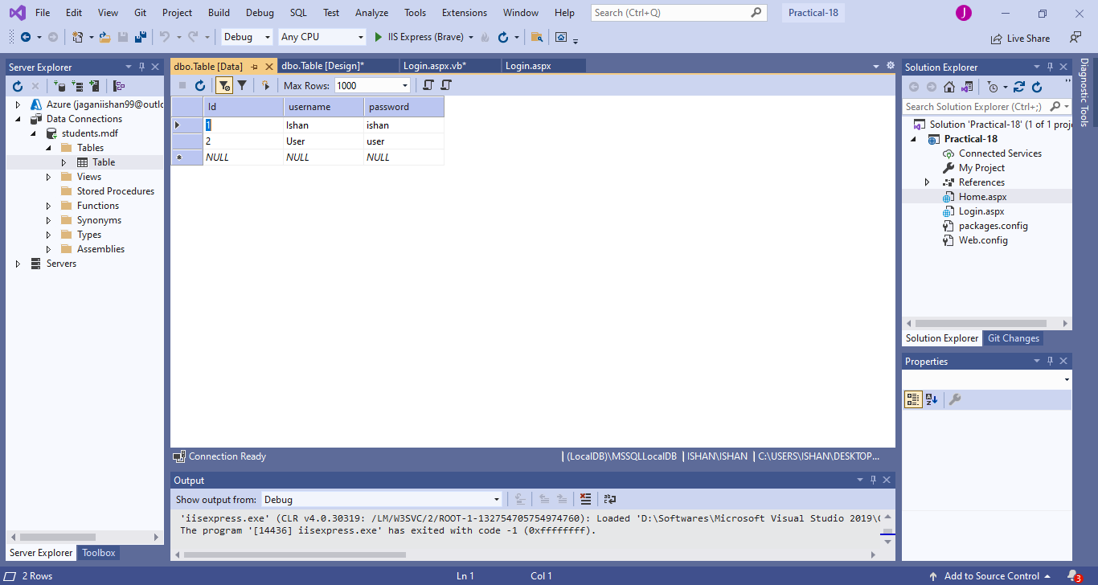

Output :

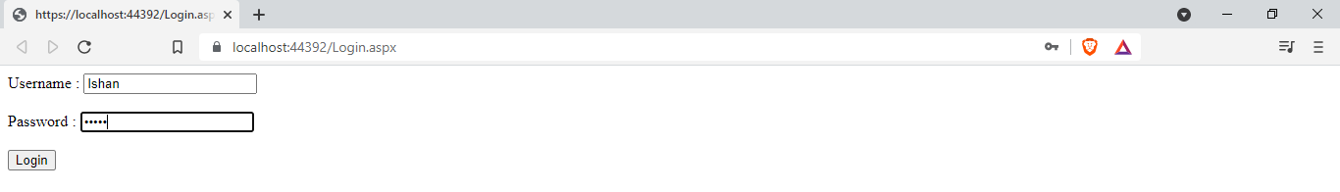



|  |  |  |  |
| --- | --- | --- | --- |
| Start Date | End/Sign Date | Faculty Sign | Remarks/Grade |
|  |  |  |  |

Practical : 19

##### **Aim: Create a web page to insert user biodata information with all validations in to the database**

Form.aspx

<%@ Page Language="vb" AutoEventWireup="false" CodeBehind="Form.aspx.vb" Inherits="Practical_19.Form" %>

<!DOCTYPE html>

<html xmlns="http://www.w3.org/1999/xhtml">

<head runat="server">

<title></title>

</head>

<body>

<form id="form1" runat="server">

<div>

<strong>Bio-Data From</strong><br />

<br />

First Name : <asp:TextBox ID="txtfname" runat="server"></asp:TextBox>

<asp:RequiredFieldValidator ID="rfvFname" runat="server" ErrorMessage="*" ControlToValidate="txtfname" ForeColor="Red"></asp:RequiredFieldValidator>

<br />

<br />

Last Name :

<asp:TextBox ID="txtlname" runat="server"></asp:TextBox>

<asp:RequiredFieldValidator ID="rfvLname" runat="server" ErrorMessage="*" ControlToValidate="txtlname" ForeColor="Red"></asp:RequiredFieldValidator>

<br />

<br />

Age :

<asp:TextBox ID="txtAge" runat="server"></asp:TextBox>

<asp:RequiredFieldValidator ID="rfvAge" runat="server" ErrorMessage="*" ControlToValidate="txtAge" ForeColor="Red"></asp:RequiredFieldValidator>

<asp:RangeValidator ID="RangeValidator1" runat="server" ErrorMessage="Please Enter Valid Age !!" ControlToValidate="txtAge" Type="Integer" MaximumValue="100" MinimumValue="18" ForeColor="Red"></asp:RangeValidator>

<br />

<br />

Gender :&nbsp;

<asp:RadioButton ID="radMale" runat="server" GroupName="gender" Text="Male" />

<asp:RadioButton ID="radfemale" runat="server" GroupName="gender" Text="Female" />

<br />

<br />

Phone :

<asp:TextBox ID="txtPhone" runat="server"></asp:TextBox>

<asp:RequiredFieldValidator ID="rfvPhone" runat="server" ErrorMessage="*" ControlToValidate="txtPhone" ForeColor="Red"></asp:RequiredFieldValidator>

<br />

<br />

Qualification :

<asp:DropDownList ID="drpQualification" runat="server">

<asp:ListItem>Diploma</asp:ListItem>

<asp:ListItem>BE</asp:ListItem>

<asp:ListItem>Masters</asp:ListItem>

</asp:DropDownList>

<asp:RequiredFieldValidator ID="rfvQualification" runat="server" ErrorMessage="*" ControlToValidate="drpQualification" ForeColor="Red"></asp:RequiredFieldValidator>

<br />

<br />

<asp:Button ID="btnSubmit" runat="server" Text="Submit" />

<br />

<br />

<asp:Label ID="successLabel" runat="server" Text="" ForeColor="LightGreen"></asp:Label>

</div>

</form>

</body>

</html>

Form.aspx.vb

Public Class Form

Inherits System.Web.UI.Page

Protected Sub Page_Load(ByVal sender As Object, ByVal e As System.EventArgs) Handles Me.Load

End Sub

Protected Sub btnSubmit_Click1(sender As Object, e As EventArgs) Handles btnSubmit.Click

Dim qualification As String

Dim gender As String

Dim ans As Integer

If radMale.Checked Then

gender = "Male"

Else

gender = "Female"

End If

If drpQualification.SelectedIndex = 0 Then

qualification = "Diploma"

ElseIf drpQualification.SelectedIndex = 1 Then

qualification = "BE"

Else

qualification = "Masters"

End If

Dim con As New SqlClient.SqlConnection("Data Source=(LocalDB)\MSSQLLocalDB;AttachDbFilename=C:\Users\ISHAN\Desktop\Databases\biodata.mdf;Integrated Security=True;Connect Timeout=30")

Dim cmd As New SqlClient.SqlCommand("Insert into Table(fname,lname,gender,phone,qualification) values('" & txtfname.Text & "','" & txtlname.Text & "','" & gender & "','" & txtPhone.Text & "','" & qualification & "')", con)

con.Open()

cmd.ExecuteNonQuery()

con.Close()

successLabel.Text = "Data Added Successfully !!"

End Sub

End Class

Output :

Before Inserting :

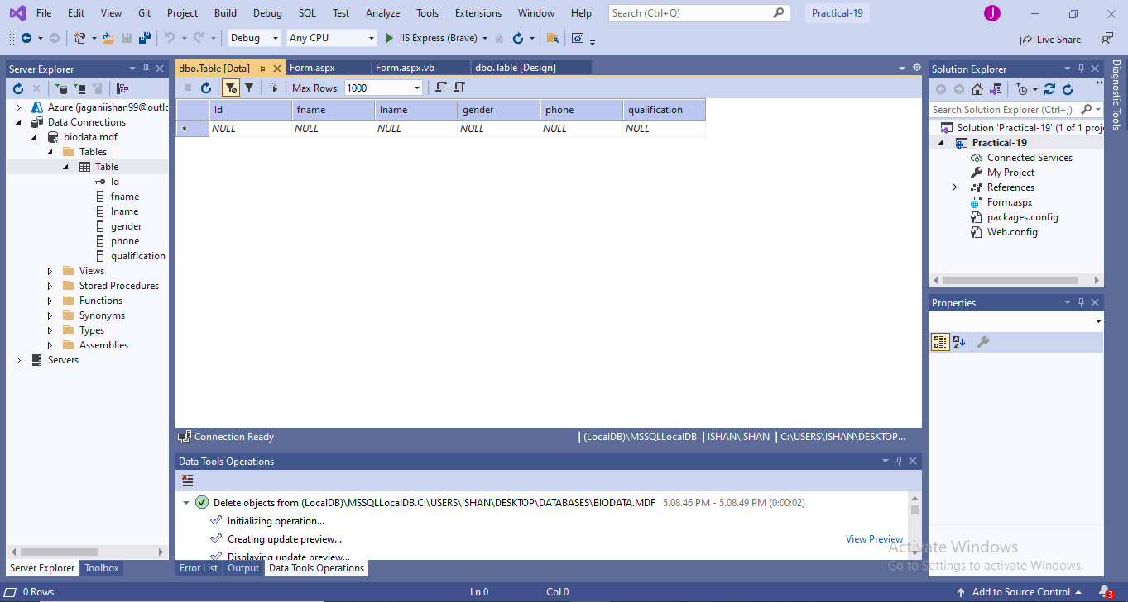

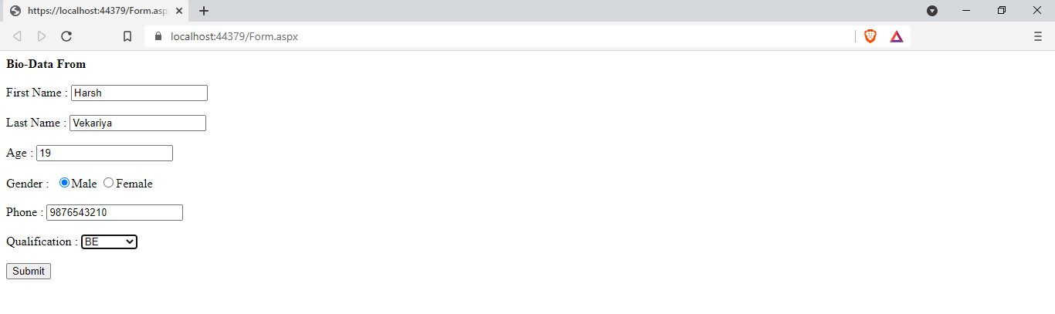

On Data Added Successfully :

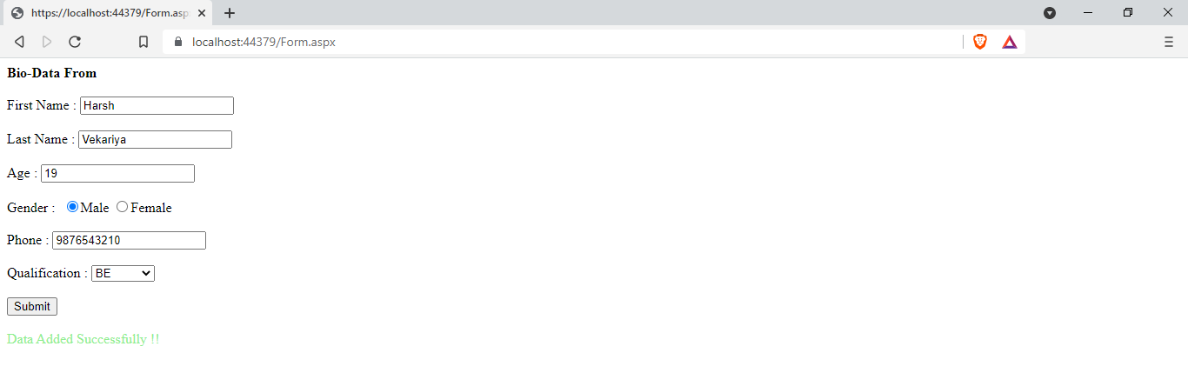

Data Inserted Successfully :

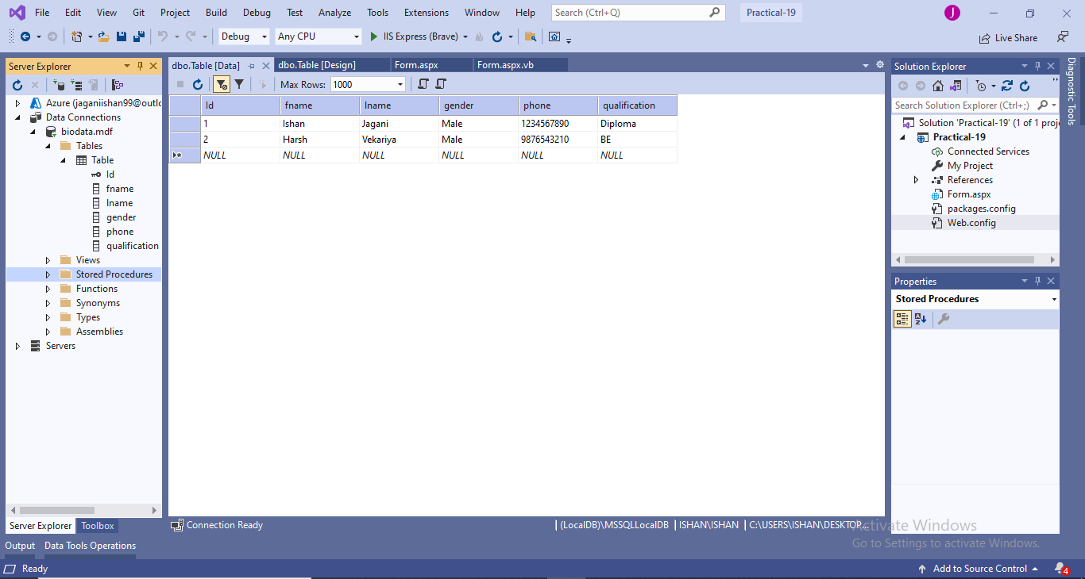

|  |  |  |  |
| --- | --- | --- | --- |
| Start Date | End/Sign Date | Faculty Sign | Remarks/Grade |
|  |  |  |  |

Practical : 20

##### **Aim: Create a webpage, that allows user to add a new username if user doesn’t exist in the database. Also create a forgot password link, to redirect user to set up his new password on authentication**

Login.aspx

<%@ Page Language="vb" AutoEventWireup="false" CodeBehind="Login.aspx.vb" Inherits="Practical_20.Login" %>

<!DOCTYPE html>

<html xmlns="http://www.w3.org/1999/xhtml">

<head runat="server">

<title></title>

</head>

<body>

<form id="form1" runat="server">

<div>

<strong>Login</strong><br />

<br />

Username :

<asp:TextBox ID="txtUsername" runat="server"></asp:TextBox>

<br />

<br />

Password :

<asp:TextBox ID="txtPwd" runat="server" TextMode="Password"></asp:TextBox>

&nbsp;<br />

<br />

<asp:Button ID="btnCreateAccount" runat="server" Text="Register Yourself" />

<asp:Button ID="btnForgotPassword" runat="server" Text="Forgot Password" />

<br />

<br />

<asp:Button ID="btnLogin" runat="server" Text="Login" />

</div>

</form>

</body>

</html>

Login.aspx.vb

Public Class Login

Inherits System.Web.UI.Page

Protected Sub Page_Load(ByVal sender As Object, ByVal e As System.EventArgs) Handles Me.Load

End Sub

Protected Sub btnLogin_Click(sender As Object, e As EventArgs) Handles btnLogin.Click

Dim con As New SqlClient.SqlConnection("Data Source=(LocalDB)\MSSQLLocalDB;AttachDbFilename=C:\Users\ISHAN\Desktop\Databases\Info.mdf;Integrated Security=True;Connect Timeout=30")

Dim ad As New SqlClient.SqlDataAdapter("select * from tblLogin where username = '" & txtUsername.Text & "' and password = '" & txtPwd.Text & "' ", con)

Dim ds As New DataSet

con.Open()

ad.Fill(ds)

con.Close()

If ds.Tables(0).Rows.Count > 0 Then

Response.Redirect("Home.aspx")

Else

Response.Write("<font color='red'>Invalid Username/Password</font>")

End If

End Sub

Protected Sub btnCreateAccount_Click(sender As Object, e As EventArgs) Handles btnCreateAccount.Click

Response.Redirect("Register.aspx")

End Sub

Protected Sub btnForgotPassword_Click(sender As Object, e As EventArgs) Handles btnForgotPassword.Click

Response.Redirect("ForgotPassword.aspx")

End Sub

End Class

Register.aspx

<%@ Page Language="vb" AutoEventWireup="false" CodeBehind="Register.aspx.vb" Inherits="Practical_20.Register" %>

<!DOCTYPE html>

<html xmlns="http://www.w3.org/1999/xhtml">

<head runat="server">

<title></title>

</head>

<body>

<form id="form1" runat="server">

<div>

<strong>Register<br />

</strong>

<br />

Username :

<asp:TextBox ID="txtUsername" runat="server"></asp:TextBox>

<br />

<br />

Password :

<asp:TextBox ID="txtPwd" runat="server" TextMode="Password"></asp:TextBox>

<br />

<br />

Confirm Password :

<asp:TextBox ID="txtCpwd" runat="server" TextMode="Password"></asp:TextBox>

<br />

<br />

Hint :

<asp:TextBox ID="txtHint" runat="server"></asp:TextBox>

<br />

<br />

<asp:Button ID="btnRegister" runat="server" Text="Register" />

<br />

<br />

<asp:Button ID="btnBackToLogin" runat="server" Text="Back to Login" />

</div>

</form>

</body>

</html>

Register.aspx.vb

Public Class Register

Inherits System.Web.UI.Page

Protected Sub Page_Load(ByVal sender As Object, ByVal e As System.EventArgs) Handles Me.Load

End Sub

Protected Sub btnRegister_Click(sender As Object, e As EventArgs) Handles btnRegister.Click

Dim con As New SqlClient.SqlConnection("Data Source=(LocalDB)\MSSQLLocalDB;AttachDbFilename=C:\Users\ISHAN\Desktop\Databases\Info.mdf;Integrated Security=True;Connect Timeout=30")

Dim cmd As New SqlClient.SqlCommand("insert into tblLogin values('" & txtUsername.Text & "','" & txtPwd.Text & "','" & txtHint.Text & "')", con)

Dim ds As New DataSet

con.Open()

cmd.ExecuteNonQuery()

con.Close()

Response.Write("Profile Creater Successfully !!")

Response.Redirect("Login.aspx")

End Sub

Protected Sub btnBackToLogin_Click(sender As Object, e As EventArgs) Handles btnBackToLogin.Click

Response.Redirect("Login.aspx")

End Sub

End Class

ForgotPassword.aspx

<%@ Page Language="vb" AutoEventWireup="false" CodeBehind="ForgotPassword.aspx.vb" Inherits="Practical_20.ForgotPassword" %>

<!DOCTYPE html>

<html xmlns="http://www.w3.org/1999/xhtml">

<head runat="server">

<title></title>

</head>

<body>

<form id="form1" runat="server">

<div>

<strong>Forgot Password</strong><br />

<br />

Enter Username :

<asp:TextBox ID="txtUsername" runat="server"></asp:TextBox>

<br />

<br />

<asp:Button ID="btnShowHint" runat="server" Text="Show Hint" />

<br />

<br />

<asp:Label ID="lblHint" runat="server" Text=""></asp:Label>

<br />

<br />

<asp:Button ID="btnBackToRegister" runat="server" Text="Back to Register" />

<asp:Button ID="btnBackToLogin" runat="server" Text="Back to Login" />

</div>

</form>

</body>

</html>

ForgotPassword.aspx.vb

Public Class ForgotPassword

Inherits System.Web.UI.Page

Protected Sub Page_Load(ByVal sender As Object, ByVal e As System.EventArgs) Handles Me.Load

End Sub

Protected Sub btnShowHint_Click(sender As Object, e As EventArgs) Handles btnShowHint.Click

Dim con As New SqlClient.SqlConnection("Data Source=(LocalDB)\MSSQLLocalDB;AttachDbFilename=C:\Users\ISHAN\Desktop\Databases\Info.mdf;Integrated Security=True;Connect Timeout=30")

Dim ad As New SqlClient.SqlDataAdapter("select * from tblLogin where username='" & txtUsername.Text & "' ", con)

Dim ds As New DataSet

con.Open()

ad.Fill(ds)

con.Close()

If ds.Tables(0).Rows.Count > 0 Then

lblHint.Text = ds.Tables(0).Rows(0).Item("hint").ToString

Else

Response.Write("<font color=red>Invalid Username</font>")

End If

End Sub

Protected Sub btnBackToLogin_Click(sender As Object, e As EventArgs) Handles btnBackToLogin.Click

Response.Redirect("Login.aspx")

End Sub

Protected Sub btnBackToRegister_Click(sender As Object, e As EventArgs) Handles btnBackToRegister.Click

Response.Redirect("Register.aspx")

End Sub

End Class

Home.aspx

<%@ Page Language="vb" AutoEventWireup="false" CodeBehind="Home.aspx.vb" Inherits="Practical_20.Home" %>

<!DOCTYPE html>

<html xmlns="http://www.w3.org/1999/xhtml">

<head runat="server">

<title></title>

</head>

<body>

<form id="form1" runat="server">

<div>

Welcome To Home Page of Ishan's Website..!!

</div>

</form>

</body>

</html>

Output :

Empty Database :

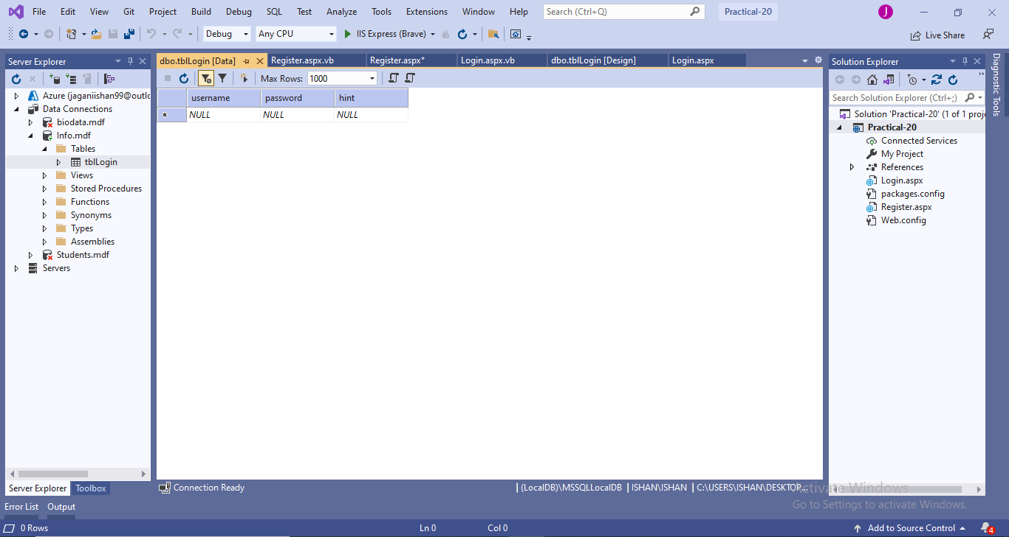

Registration :

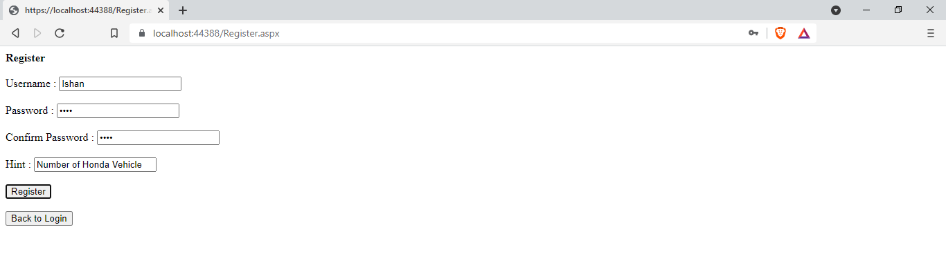

After Registration :

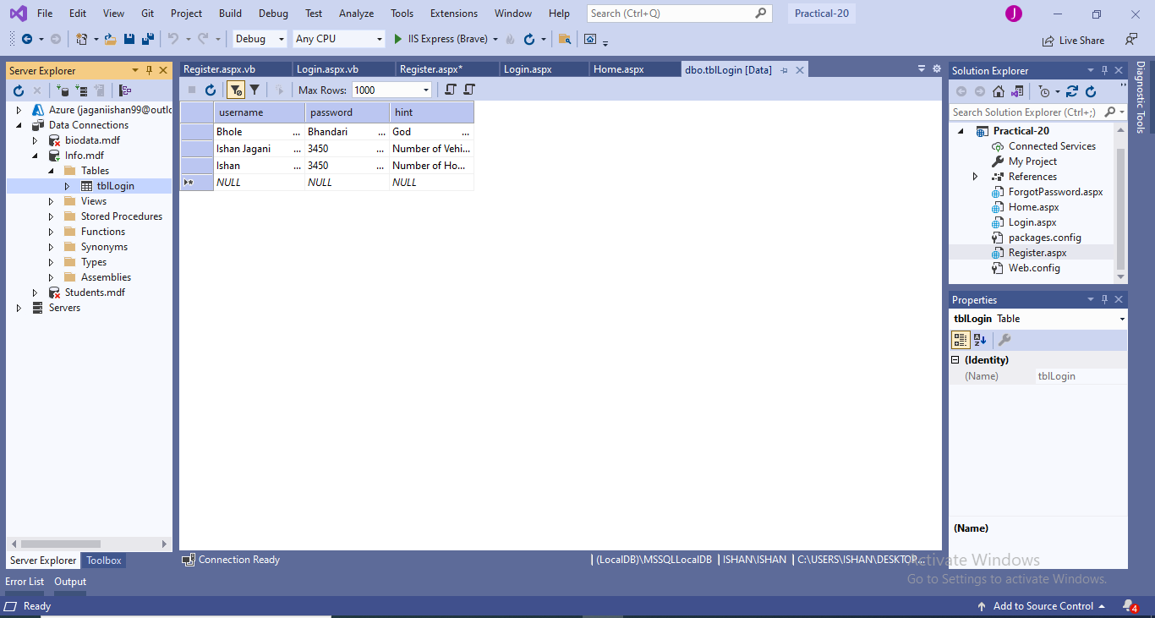

Login:

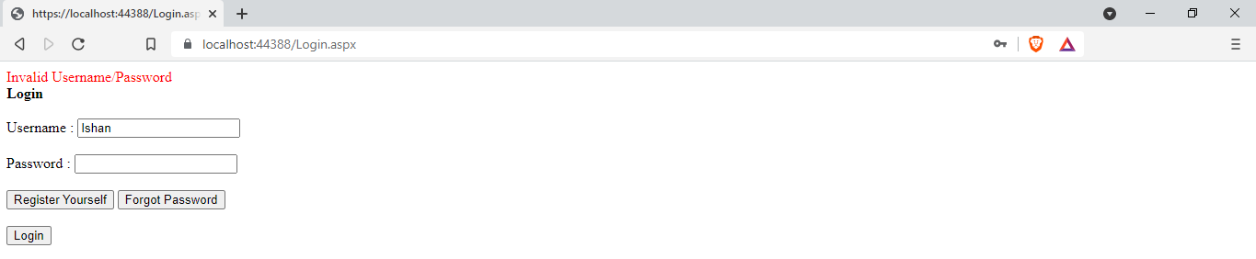

On Successful Login:



Forgot Password:

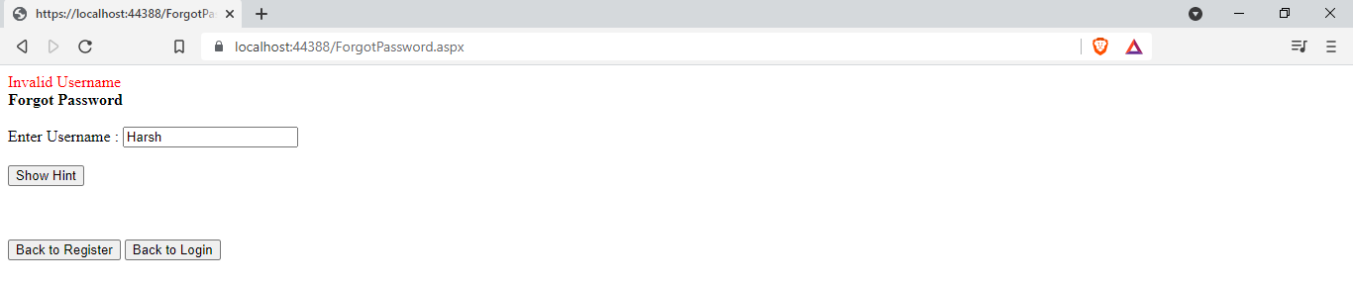

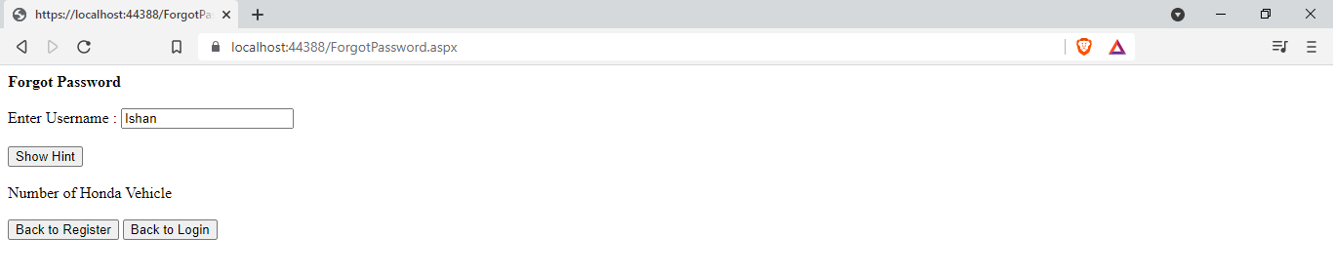

|  |  |  |  |
| --- | --- | --- | --- |
| Start Date | End/Sign Date | Faculty Sign | Remarks/Grade |
|  |  |  |  |

Practical : 21

##### **Aim: Create a webpage to display the information about user on his homepage once he has logged in through the login form**

Login.aspx

<%@ Page Language="vb" AutoEventWireup="false" CodeBehind="Login.aspx.vb" Inherits="Practical_21.Login" %>

<!DOCTYPE html>

<html xmlns="http://www.w3.org/1999/xhtml">

<head runat="server">

<title></title>

</head>

<body>

<form id="form1" runat="server">

<div style="font-weight: 700">

Login<br />

<br />

Username :

<asp:TextBox ID="txtUsername" runat="server" />

<br /><br />

Password :

<asp:TextBox ID="txtPwd" runat="server" TextMode="Password"/>

<br /><br />

<asp:Button ID="btnSubmit" runat="server" Text="Login" />

</div>

</form>

</body>

</html>

Login.aspx.vb

Public Class Login

Inherits System.Web.UI.Page

Protected Sub Page_Load(ByVal sender As Object, ByVal e As System.EventArgs) Handles Me.Load

End Sub

Protected Sub btnSubmit_Click(sender As Object, e As EventArgs) Handles btnSubmit.Click

Dim con As New SqlClient.SqlConnection("Data Source=(LocalDB)\MSSQLLocalDB;AttachDbFilename=C:\Users\ISHAN\Desktop\Databases\User.mdf;Integrated Security=True;Connect Timeout=30")

Dim ad As New SqlClient.SqlDataAdapter("select * from UserData where Username = '" & txtUsername.Text & "' and Password = '" & txtPwd.Text & "' ", con)

Dim dt As New DataTable

con.Open()

ad.Fill(dt)

con.Close()

If dt.Rows.Count > 0 Then

Session("username") = txtUsername.Text

Response.Redirect("Home.aspx")

Else

Response.Write("<font color='red'>Invalid Username/Password</font>")

End If

End Sub

End Class

Home.aspx

<%@ Page Language="vb" AutoEventWireup="false" CodeBehind="Home.aspx.vb" Inherits="Practical_21.Home" %>

<!DOCTYPE html>

<html xmlns="http://www.w3.org/1999/xhtml">

<head runat="server">

<title></title>

</head>

<body>

<form id="form1" runat="server">

<div>

Username :

<asp:Label ID="lblUsername" runat="server"/>

<br /><br />

Age :

<asp:Label Id="lblAge" runat="server" />

</div>

</form>

</body>

</html>

[Home.aspx.vb](http://Home.aspx.vb)

Public Class Home

Inherits System.Web.UI.Page

Protected Sub Page_Load(ByVal sender As Object, ByVal e As System.EventArgs) Handles Me.Load

If Session("username") = "" Then

Response.Redirect("Login.aspx")

Else

Dim con As New SqlClient.SqlConnection("Data Source=(LocalDB)\MSSQLLocalDB;AttachDbFilename=C:\Users\ISHAN\Desktop\Databases\User.mdf;Integrated Security=True;Connect Timeout=30")

Dim ad As New SqlClient.SqlDataAdapter("select Username,Age from UserData where Username = " & Session("Username"), con)

Dim dt As New DataTable

con.Open()

ad.Fill(dt)

con.Close()

lblUsername.Text = dt.Rows(0).Item(0)

lblAge.Text = dt.Rows(0).Item(1)

End If

End Sub

End Class

Output :

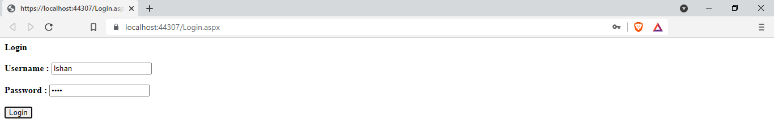

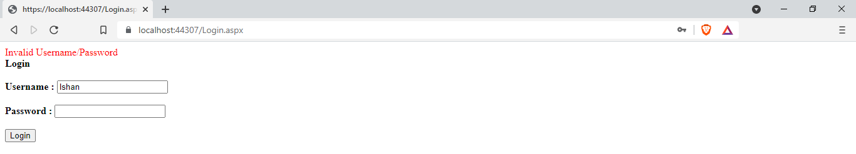

On Successful Login :

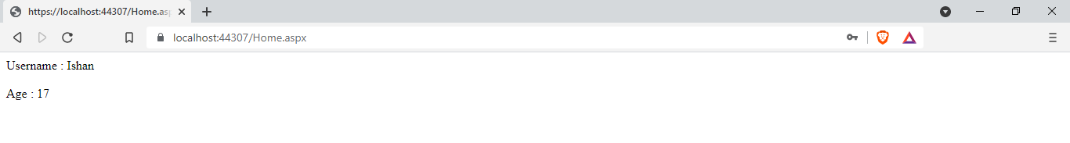

|  |  |  |  |
| --- | --- | --- | --- |
| Start Date | End/Sign Date | Faculty Sign | Remarks/Grade |
|  |  |  |  |

Practical : 22

##### **Aim: Write an exercise, to allow the user to ADD, UPDATE, MODIFY his profile once he has logged into the website using Bound and Unbound Controls.**

Register.aspx

<%@ Page Language="vb" AutoEventWireup="false" CodeBehind="Register.aspx.vb" Inherits="Practical_22.Register" %>

<!DOCTYPE html PUBLIC "-//W3C//DTD XHTML 1.0 Transitional//EN" "http://www.w3.org/TR/xhtml1/DTD/xhtml1-transitional.dtd">

<html xmlns="http://www.w3.org/1999/xhtml">

<head runat="server">

<title></title>

</head>

<body>

<form id="form1" runat="server">

<div>

<strong>Ishan Jagani</strong><br />

<br/>

<asp:Label ID ="lblTitle" runat ="server" Text ="Register" style="font-weight: 700"/>

<br/><br/>

Username : <asp:TextBox ID ="txtUsername" runat ="server" PlaceHolder ="Username" />

<br/><br/>

Name :

<asp:TextBox ID ="txtName" runat ="server" PlaceHolder ="Name" />

<br/><br/>

Age :

<asp:TextBox ID ="txtAge" runat ="server" PlaceHolder ="Age" TextMode ="number" />

<br/><br/>

Password Password :

<asp:TextBox ID ="txtPassword" runat ="server" PlaceHolder ="Password" TextMode ="password"/>

<br/><br/>

<asp:Button ID ="btnRegister" runat ="server" Text ="Register" />

<br/><br/>

<asp:HyperLink ID ="hlLogin" runat ="server" Text ="Already have Account? " NavigateUrl ="~/Login.aspx"/>

<br />

<br />

<asp:Label ID ="lblAlert" runat ="server" ForeColor ="red"/>

</div>

</form>

</body>

</html>

Register.aspx.vb

Imports System.Data.SqlClient

Public Class Register

Inherits System.Web.UI.Page

Protected Sub Page_Load(ByVal sender As Object, ByVal e As System.EventArgs) Handles Me.Load

End Sub

Protected Sub btnRegister_Click(sender As Object, e As EventArgs) Handles btnRegister.Click

Try

Dim con As New SqlConnection

con.ConnectionString = "Data Source=(LocalDB)\MSSQLLocalDB;AttachDbFilename=C:\Users\ISHAN\Desktop\Databases\UserDetails.mdf;Integrated Security=True;Connect Timeout=30"

Dim cmd As New SqlCommand

cmd.Connection = con

cmd.CommandText = "insert into UserInfo values ('" & txtUsername.Text & "','" & txtName.Text & "','" & txtAge.Text & "','" & txtPassword.Text & "')"

con.Open()

cmd.ExecuteNonQuery()

con.Close()

Response.Redirect("~/Login.aspx")

Catch ex As Exception

lblAlert.Text = "This user is already registered with us!"

End Try

End Sub

End Class

Login.aspx

<%@ Page Language="vb" AutoEventWireup="false" CodeBehind="Login.aspx.vb" Inherits="Practical_22.Login" %>

<!DOCTYPE html PUBLIC "-//W3C//DTD XHTML 1.0 Transitional//EN" "http://www.w3.org/TR/xhtml1/DTD/xhtml1-transitional.dtd">

<html xmlns="http://www.w3.org/1999/xhtml">

<head runat="server">

<title></title>

</head>

<body>

<form id="form1" runat="server">

<div>

<strong>Ishan Jagani</strong><br/>

<br />

<strong>

<asp:Label ID ="lblTitle" runat ="server" Text ="Login" />

<br/></strong><br/>

Username :

<asp:TextBox ID ="txtUsername" runat ="server" PlaceHolder ="Username" />

<br/><br/>

Password :

<asp:TextBox ID ="txtPassword" runat ="server" PlaceHolder ="Password" TextMode ="password" />

<br/><br/>

<asp:Button ID ="btnLogin" runat ="server" Text ="Login" />

<br/><br/>

<asp:HyperLink ID ="hlRegister" runat ="server" Text ="Not Registered?" NavigateUrl ="Register.aspx"/>

<br />

<br />

<asp:Label ID ="lblAlert" runat ="server" ForeColor ="red"/>

</div>

</form>

</body>

</html>

Login.aspx.vb

Imports System.Data.SqlClient

Public Class Login

Inherits System.Web.UI.Page

Protected Sub btnLogin_Click(sender As Object, e As EventArgs) Handles btnLogin.Click

Try

Dim con As New SqlConnection

con.ConnectionString = "Data Source=(LocalDB)\MSSQLLocalDB;AttachDbFilename=C:\Users\ISHAN\Desktop\Databases\UserDetails.mdf;Integrated Security=True;Connect Timeout=30"

Dim cmd As New SqlCommand("select * from UserInfo where Username = '" & txtUsername.Text & "' and Password = '" & txtPassword.Text & "' ", con)

Dim ad As New SqlDataAdapter(cmd)

Dim ds As New DataSet

con.Open()

ad.Fill(ds)

con.Close()

If ds.Tables(0).Rows.Count > 0 Then

Session("username") = txtUsername.Text

Response.Redirect("~/Home.aspx")

Else

lblAlert.Text = "Wrong Username or Password!"

End If

Catch ex As Exception

Response.Write(ex)

End Try

End Sub

End Class

Home.aspx

<%@ Page Language="vb" AutoEventWireup="false" CodeBehind="Home.aspx.vb" Inherits="Practical_22.Home" %>

<!DOCTYPE html PUBLIC "-//W3C//DTD XHTML 1.0 Transitional//EN" "http://www.w3.org/TR/xhtml1/DTD/xhtml1-transitional.dtd">

<html xmlns="http://www.w3.org/1999/xhtml">

<head runat="server">

<title></title>

</head>

<body>

<form id="form1" runat="server">

<div align ="center">

Ishan Jagani<br/>

<asp:Label ID ="lblTitle" runat ="server" Text ="Your Details" />

<br/><br/>

<asp:Label ID ="lblName" runat ="server" Text ="Name: " />

<asp:Label ID ="lblNameVal" runat ="server" Text ="" />

<br/><br/>

<asp:Label ID ="lblUsername" runat ="server" Text ="Username: "/>

<asp:Label ID ="lblUsernameVal" runat ="server" Text ="" />

<br/><br/>

<asp:Label ID ="lblAge" runat ="server" Text ="Age: " />

<asp:Label ID ="lblAgeVal" runat ="server" Text ="" />

<br/><br/>

<asp:HyperLink ID ="hlEditDetails" runat ="server" Text ="Edit Details" NavigateUrl ="~/EditDetails.aspx" />

</div>

</form>

</body>

</html>

[Home.aspx.vb](http://Home.aspx.vb)

Imports System.Data.SqlClient

Public Class Home

Inherits System.Web.UI.Page

Protected Sub Page_Load(ByVal sender As Object, ByVal e As System.EventArgs) Handles Me.Load

Try

Dim con As New SqlConnection

con.ConnectionString = "Data Source=(LocalDB)\MSSQLLocalDB;AttachDbFilename=C:\Users\ISHAN\Desktop\Databases\UserDetails.mdf;Integrated Security=True;Connect Timeout=30"

Dim cmd As New SqlCommand("select Username, Name, Age from UserInfo where Username = " + Session("username"), con)

Dim ad As New SqlDataAdapter(cmd)

Dim ds As New DataSet

con.Open()

ad.Fill(ds)

con.Close()

lblNameVal.Text = ds.Tables(0).Rows(0).Item(0)

lblUsernameVal.Text = ds.Tables(0).Rows(0).Item(1)

lblAgeVal.Text = ds.Tables(0).Rows(0).Item(2)

Catch ex As Exception

Response.Redirect("~/Login.aspx")

End Try

End Sub

End Class

EditDetails.aspx

<%@ Page Language="vb" AutoEventWireup="false" CodeBehind="EditDetails.aspx.vb" Inherits="Practical_22.EditDetails" %>

<!DOCTYPE html PUBLIC "-//W3C//DTD XHTML 1.0 Transitional//EN" "http://www.w3.org/TR/xhtml1/DTD/xhtml1-transitional.dtd">

<html xmlns="http://www.w3.org/1999/xhtml">

<head runat="server">

<title></title>

</head>

<body>

<form id="form1" runat="server">

<div>

Ishan Jagani<br />

<br/>

<asp:Label ID ="title_label" runat ="server" Text ="Edit Details"/>

<br />

<br/>Keep the Textbox empty for the detail you don't want to edit.<br />

<br/>

<asp:TextBox ID ="txtName" runat ="server" PlaceHolder ="Name" />

<br/><br/>

<asp:TextBox ID ="txtAge" runat ="server" PlaceHolder ="Age" TextMode ="number" />

<br/><br/>

<asp:Button ID ="btnSave" runat ="server" Text ="Save" />

<br/><br/>

</div>

</form>

</body>

</html>

EditDetails.aspx.vb

Imports System.Data.SqlClient

Public Class EditDetails

Inherits System.Web.UI.Page

Protected Sub btnSave_Click(sender As Object, e As EventArgs) Handles btnSave.Click

Try

Dim con As New SqlConnection

con.ConnectionString = "Data Source=(LocalDB)\MSSQLLocalDB;AttachDbFilename=C:\Users\ISHAN\Desktop\Databases\UserDetails.mdf;Integrated Security=True;Connect Timeout=30"

Dim cmd As New SqlCommand

cmd.Connection = con

Dim usernm As String = ""

Dim age As String = ""

If (txtName.Text <> "") Then

usernm = "'" + txtName.Text + "'"

cmd.CommandText = "update UserInfo set Name = " + usernm + " where Username = " + Session("username")

End If

If (txtAge.Text <> "") Then

age = "'" + txtAge.Text + "'"

cmd.CommandText = "update UserInfo set Age = " + age + " where Username = " + Session("username")

End If

If (txtName.Text <> "" And txtAge.Text <> "") Then

cmd.CommandText = "update UserInfo set Name = " + usernm + ", Age = " + age + " where Username = " + Session("username")

End If

Dim ds As New DataSet

con.Open()

cmd.ExecuteNonQuery()

con.Close()

Response.Redirect("~/Login.aspx")

Catch ex As Exception

End Try

End Sub

End Class

Output :

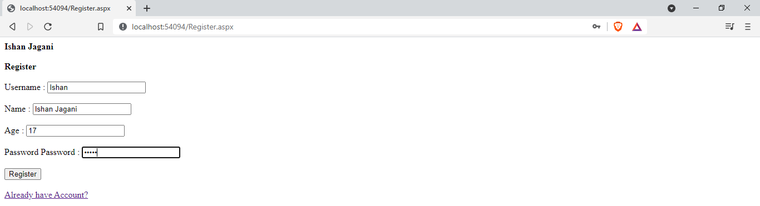

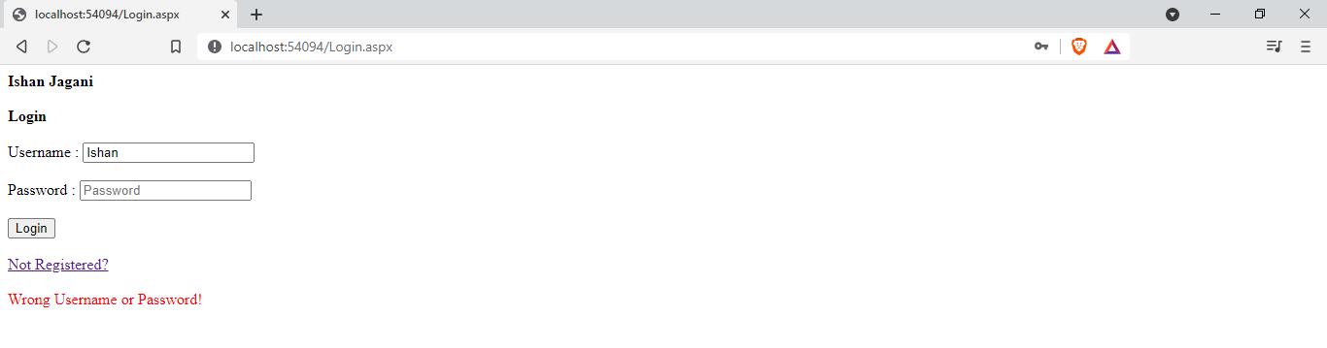

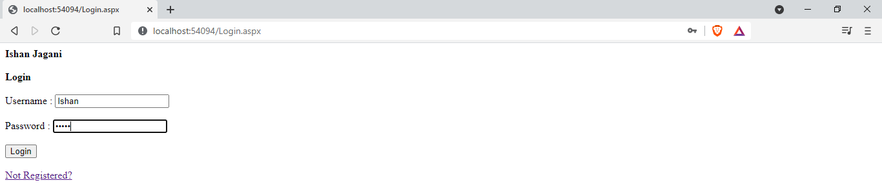

On Successful Login :

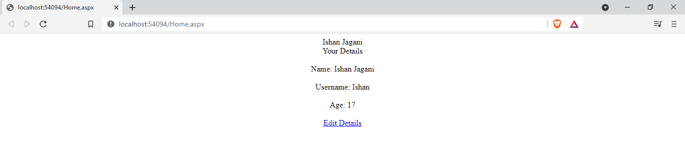

Edit Details:

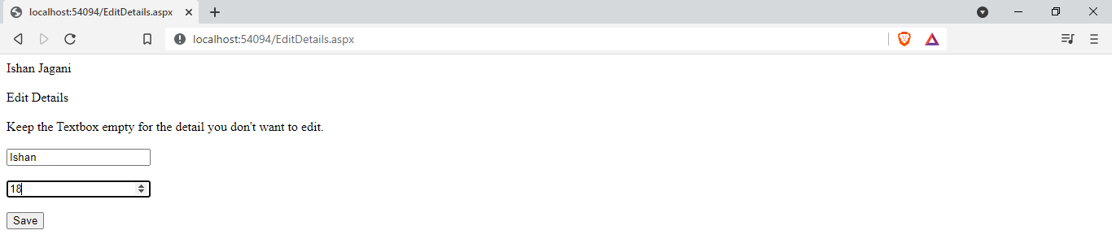

After Edit Details :

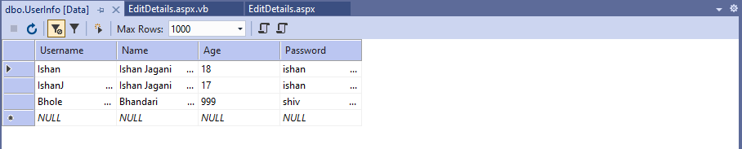

|  |  |  |  |
| --- | --- | --- | --- |
| Start Date | End/Sign Date | Faculty Sign | Remarks/Grade |
|  |  |  |  |

Practical : 23

##### **Aim: Create a webpage to bind the user data from database into a gridview dynamically.**

Home.aspx

<%@ Page Language="vb" AutoEventWireup="false" CodeBehind="Home.aspx.vb" Inherits="Practical_23.Home" %>

<!DOCTYPE html>

<html xmlns="http://www.w3.org/1999/xhtml">

<head runat="server">

<title></title>

</head>

<body>

<form id="form1" runat="server">

<div>

<asp:Button ID="btnFetch" runat="server" Text="Fetch Data" />

<br /><br />

<asp:GridView ID="gvData" runat="server" />

</div>

</form>

</body>

</html>

[Home.aspx.vb](http://Home.aspx.vb)

Public Class Home

Inherits System.Web.UI.Page

Protected Sub Page_Load(ByVal sender As Object, ByVal e As System.EventArgs) Handles Me.Load

End Sub

Protected Sub btnFetch_Click(sender As Object, e As EventArgs) Handles btnFetch.Click

Dim con As New SqlClient.SqlConnection("Data Source=(LocalDB)\MSSQLLocalDB;AttachDbFilename=C:\Users\ISHAN\Desktop\Databases\DummyData.mdf;Integrated Security=True;Connect Timeout=30")

Dim ad As New SqlClient.SqlDataAdapter("select * from Data", con)

Dim ds As New DataTable

con.Open()

ad.Fill(ds)

con.Close()

gvData.DataSource = ds

gvData.DataBind()

End Sub

End Class

Output :

Dummy Data In Database :

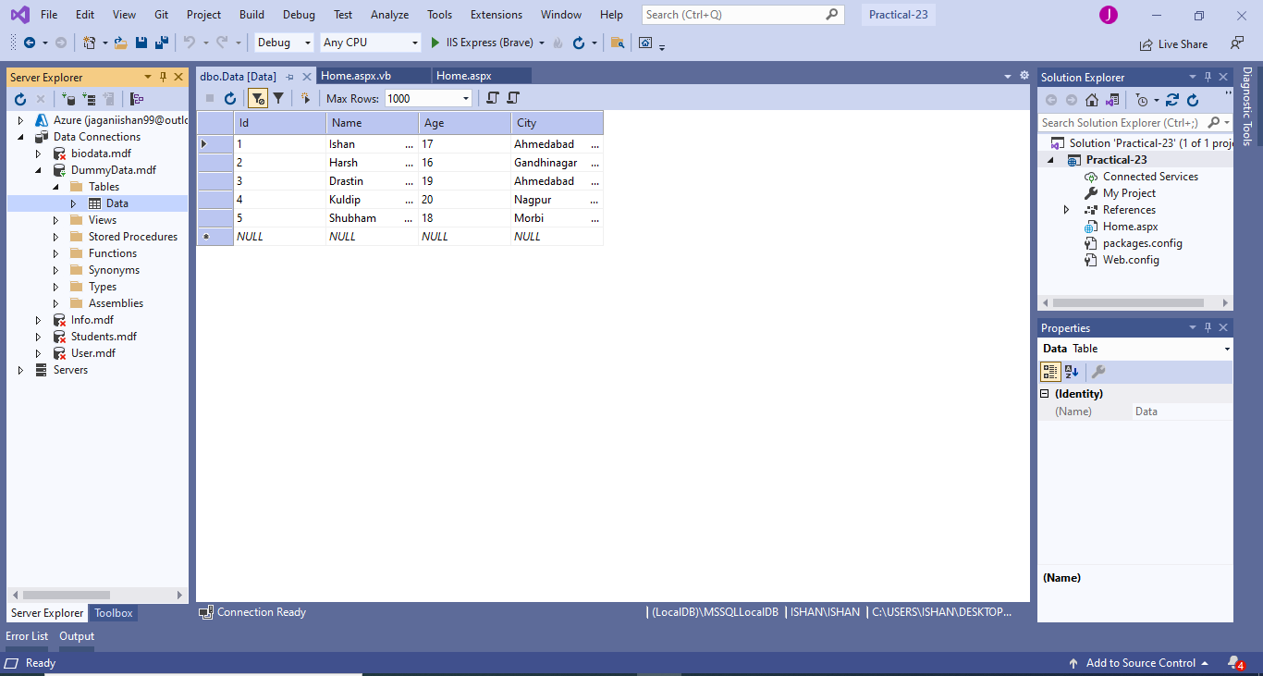



After Fetching Data :

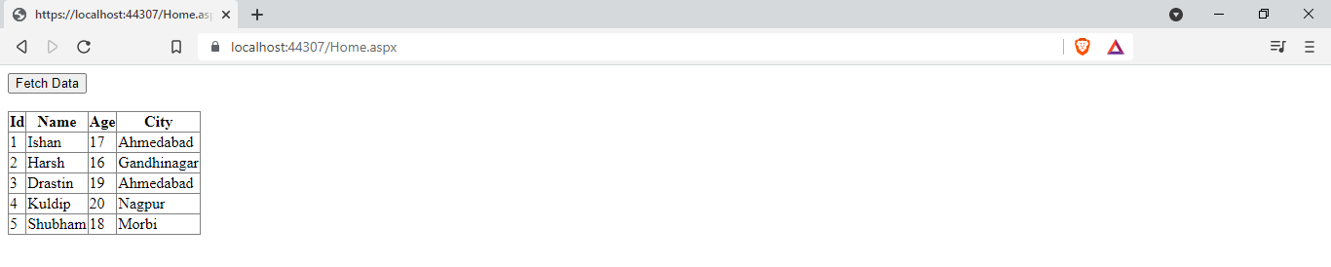

|  |  |  |  |
| --- | --- | --- | --- |
| Start Date | End/Sign Date | Faculty Sign | Remarks/Grade |
|  |  |  |  |